CREATE AND MANAGE LOCAL REPOSITORY USING GIT

AIM:

To create and manage local repository using GIT.

ALGORITHM:

* Step 1: Download git from your browser and install it.
* Step 2: In desktop, right click and select Git bash here.
* Step: This opens the git bash, there create a new repository using mkdir command and use cd (Change Directory) command to change the directory.
* Step 3: To set your Git username, run the git config –global user.name command and to set your Git email, run the git config –global user.email command.
* Step 4: To initiate the created repository, use git init command.
* Step 5: Use touch command to create three empty files that are html file, text file and python file.
* Step 6: To add all the three files to the index (Staging Area) use the git add . command.
* Step 7: Using git commit –m “value” command we can move all the files from index to a commit.
* Step 8: By the use of git status command we candisplay the state of the repository and staging area.
* Step 9: Use git log command to review and read a history of everything that happens to a repository but if you want to specifically see for a file use git log –oneline file_name.
* Step 10: The git branch command allows you to create, list, rename and delete branches and the git checkout command lets you navigate between the branches created by git branch.

OUTPUT:

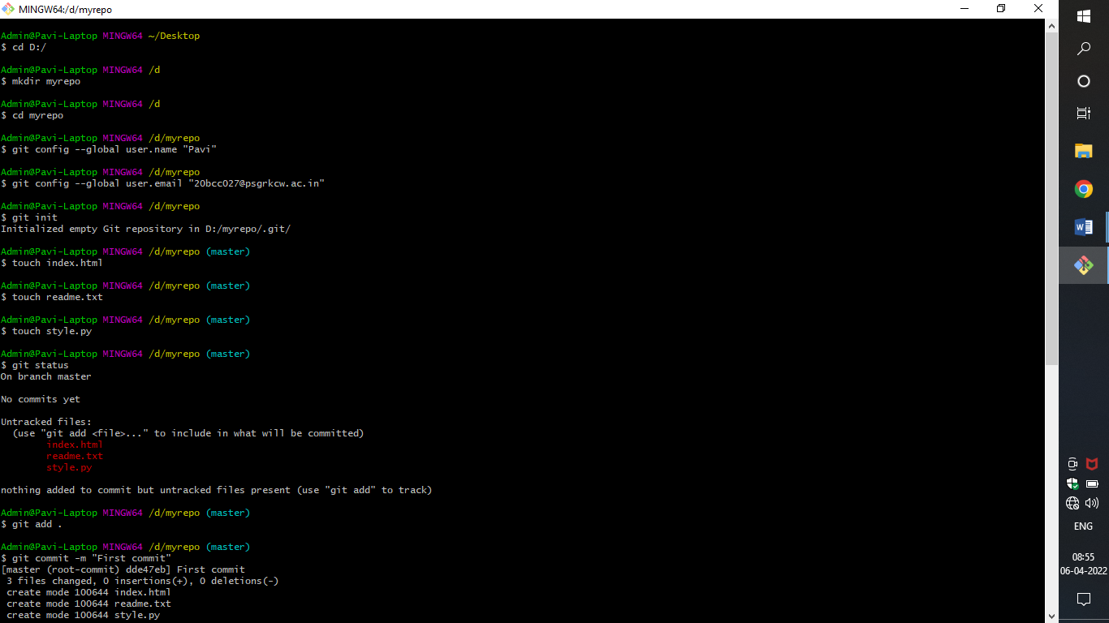

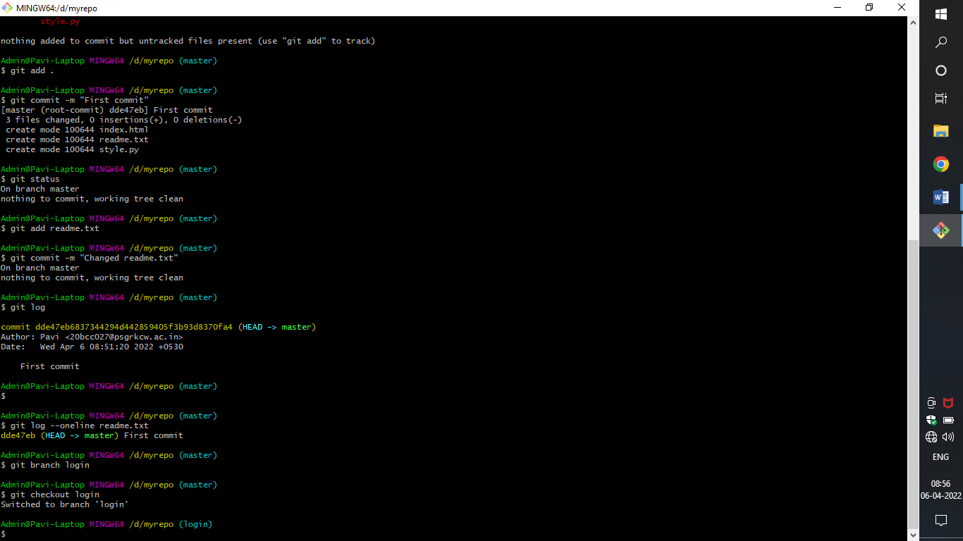

RESULT:

Hence a local repository has been created and managed using GIT.

**REMOTE REPOSITORY**

**AIM:**

To create and manage a remote repository using GIT.

**ALGORITHM:**

* Step 1: Sign up to your git hub account and click the plus option on the top right then click new repository.
* Step 2: Fill in your repository name and description then select public. Also it is recommended to select add a readme file ,add .gitignore and choose a license and click on create repository
* Step 3: In your repository start by either creating a new file or uploading an existing file.
* Step 4: You can create or upload many versions of your file and commit the changes.
* Step 5: By using fork we can copy the entire public repository of any other users in to own account also fork make changes to a project without affecting the original repository.
* Step 6: To use fork login with another account and Copy and Paste URL of repository then just click on fork to clone to others account. Suppose we want to fork public repository “Calc_Cog”. So, search for “Calc_Cog” github repository on google and once it is opened clicked on “Fork button” from the top of the github web page.
* Step 7: After fork it will be added in your local repository and you can check it from insights tab.
* Step 8: To delete the repository, open the desired repository you want to delete and go to the settings option. There you will see delete repository button to delete it.
* Step 9: Now, if you want to download a repository in local machine, then git clone command is used followed by path to repository. In GitHub the path of repository can be known through clone or download button.

**OUTPUT:**

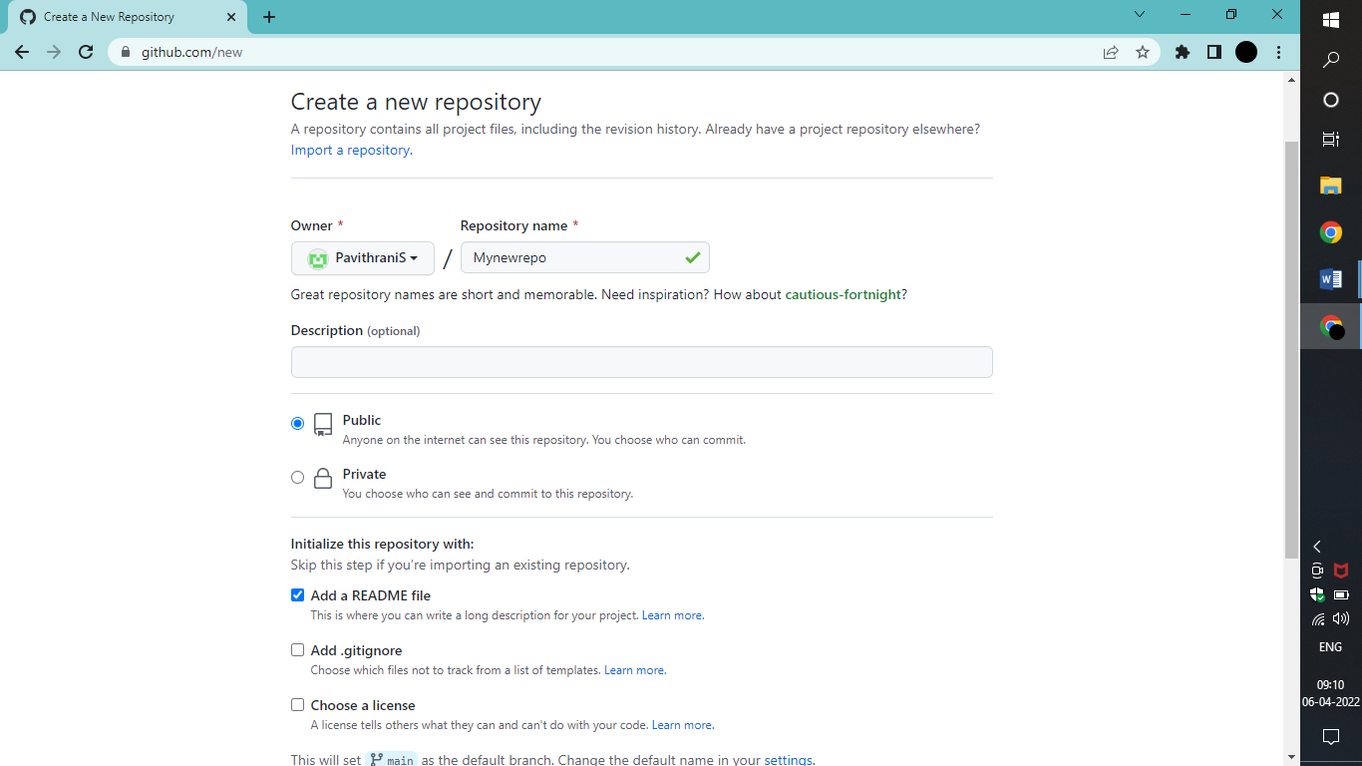

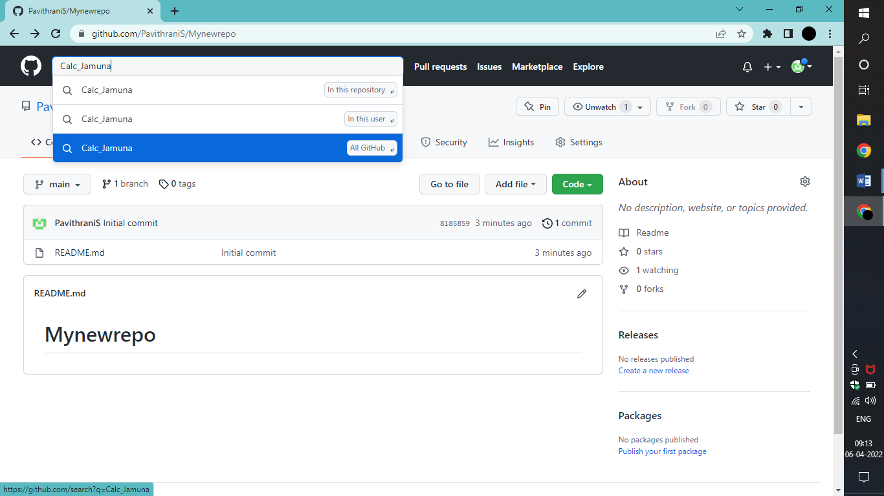

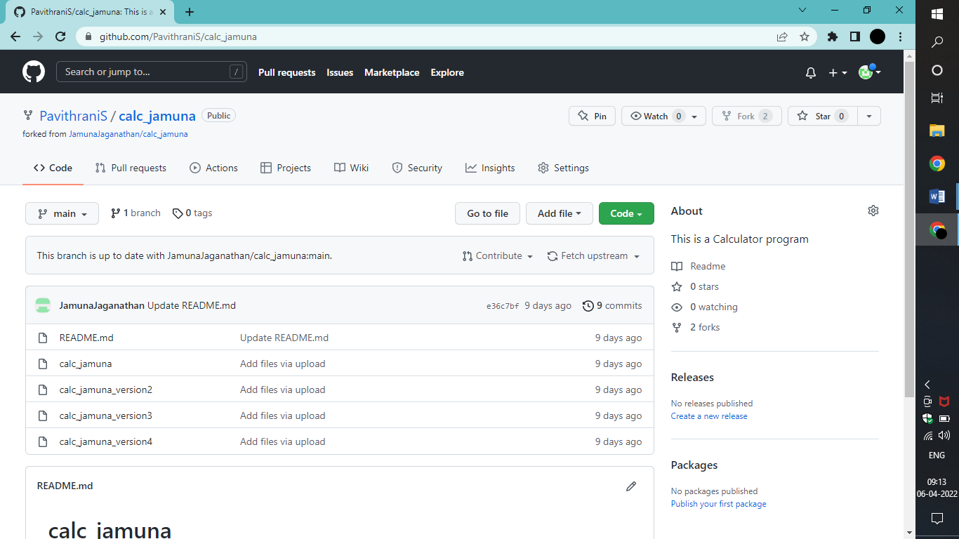

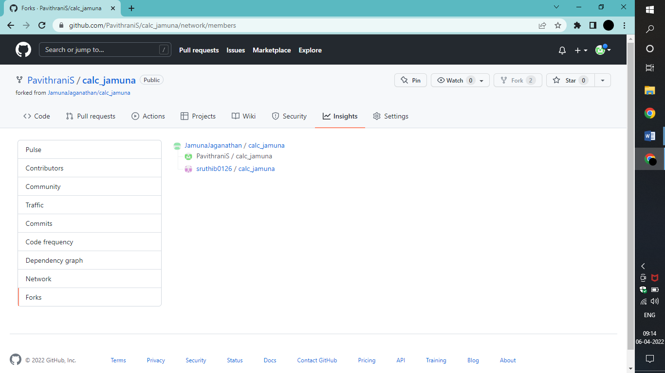

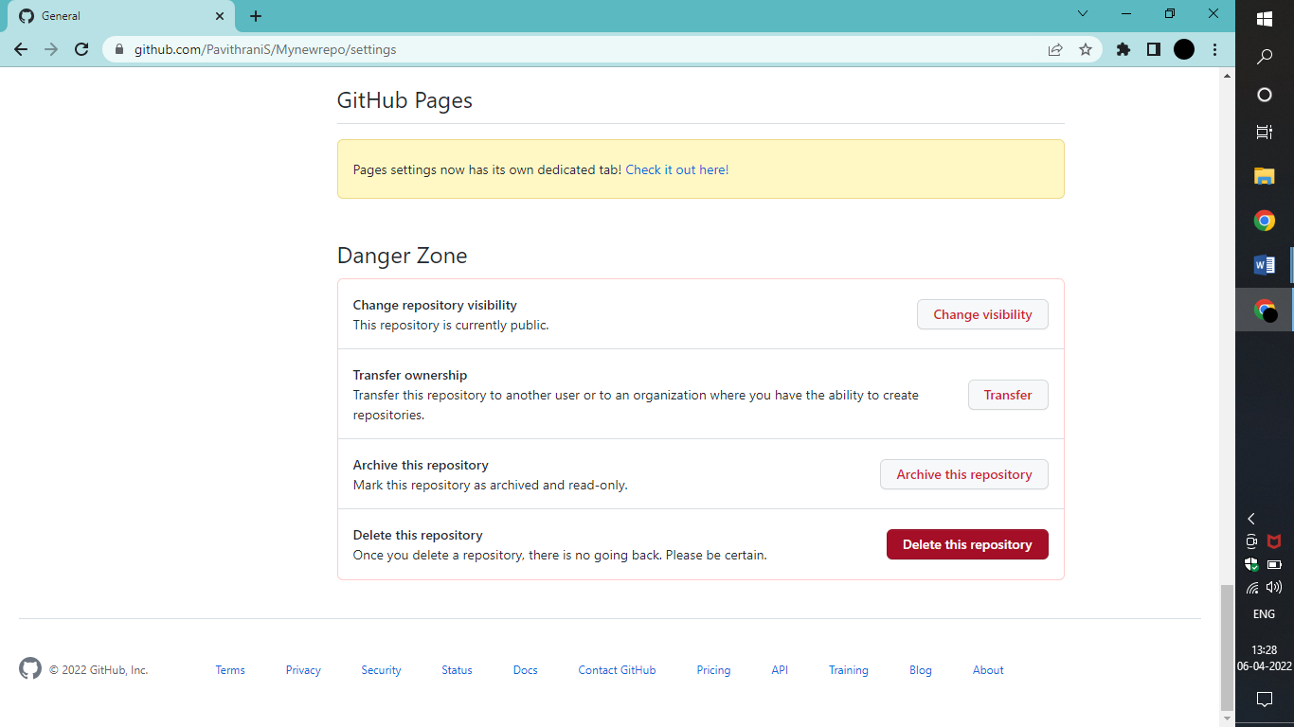

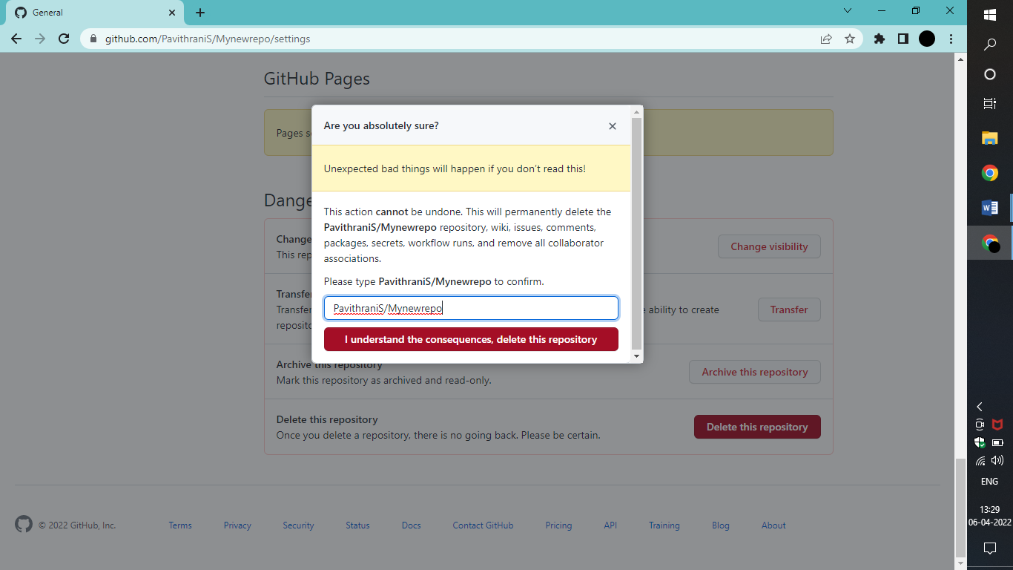

**RESULT:**

Hence a remote repository has been created and managed using GIT.

**CREATE AND PUSH A FILE FROM LOCAL REPOSITORY TO REMOTE REPOSITORY**

**AIM:**

To create and push a file from local repository to remote repository in git.

**ALGORITHM:**

* Step1: Right click on your desktop and select git bash to open the git bash.
* Step2: To create a repository use the mkdir followed by the name of the repository, for example “mkdir devops7”.
* Step3: Get into the repository by using the command “cd devops7”
* Step4: Using the command “git init” initialize the directory you created.
* Step5: Create a file using the command “touch index.html” and check if it is staged or not using the “git status” command.
* Step6: To add values to the created file use “nano index.html” command which will open the nano editor, there you can type the html code.
* Step7: To save the file press ctrl+o and press enter. To exit the nano editor press ctrl+x.
* Step8: To list the content inside the created file use “cat index.html” command and stage this file using “git add index.html” command.
* Step9: To commit this file to the local repository type “git commit –m”Added index.html”.
* Step10: By using the “git status” command again check the status of the file.
* Step11: Now to push the file to the remote repository sign in to your repository and copy the https link and go back to the terminal.
* Step12: To add this repository as an origin location use “git remote add origin <https://github.com/PavithraniS/Calc_Pavi.git>” where <https://github.com/PavithraniS/Calc_Pavi.git> is the link of your remote repository.
* Step13: Using the “git push origin master” command you can push the file to the remote repository.
* Step14: If verification needed reenter the code given and verify your account.
* Step15: Now locate the remote repository and reload the page where a new branch called master would be added.
* Step16: Change the branch from main to master by clicking the drop down box and there you can see the index.html file.

**OUTPUT:**

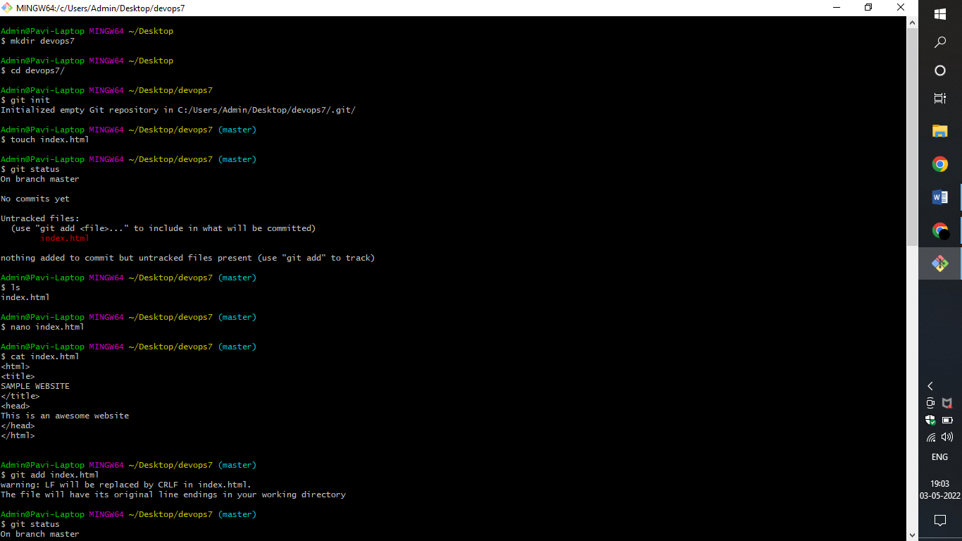

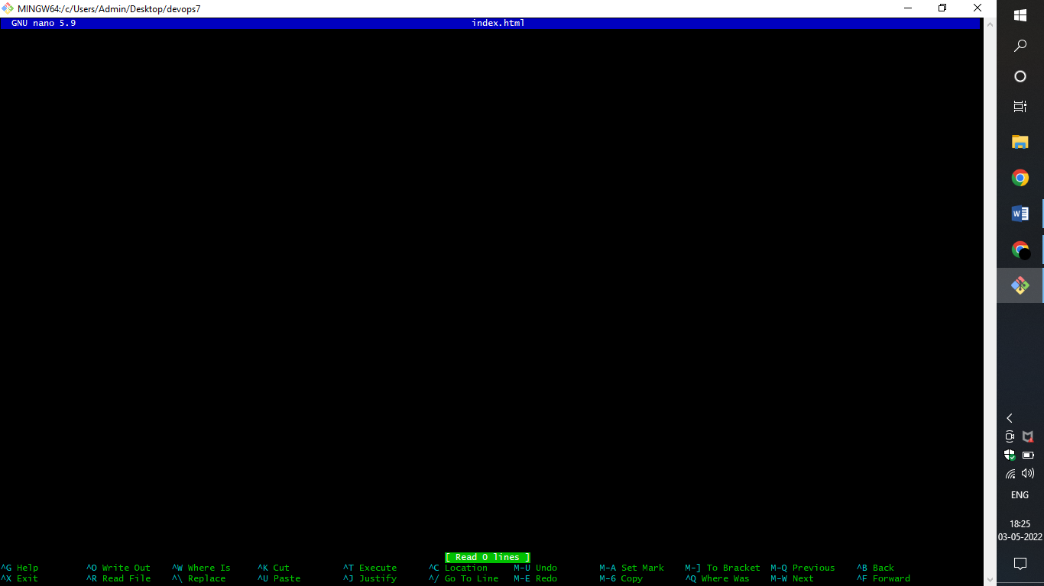

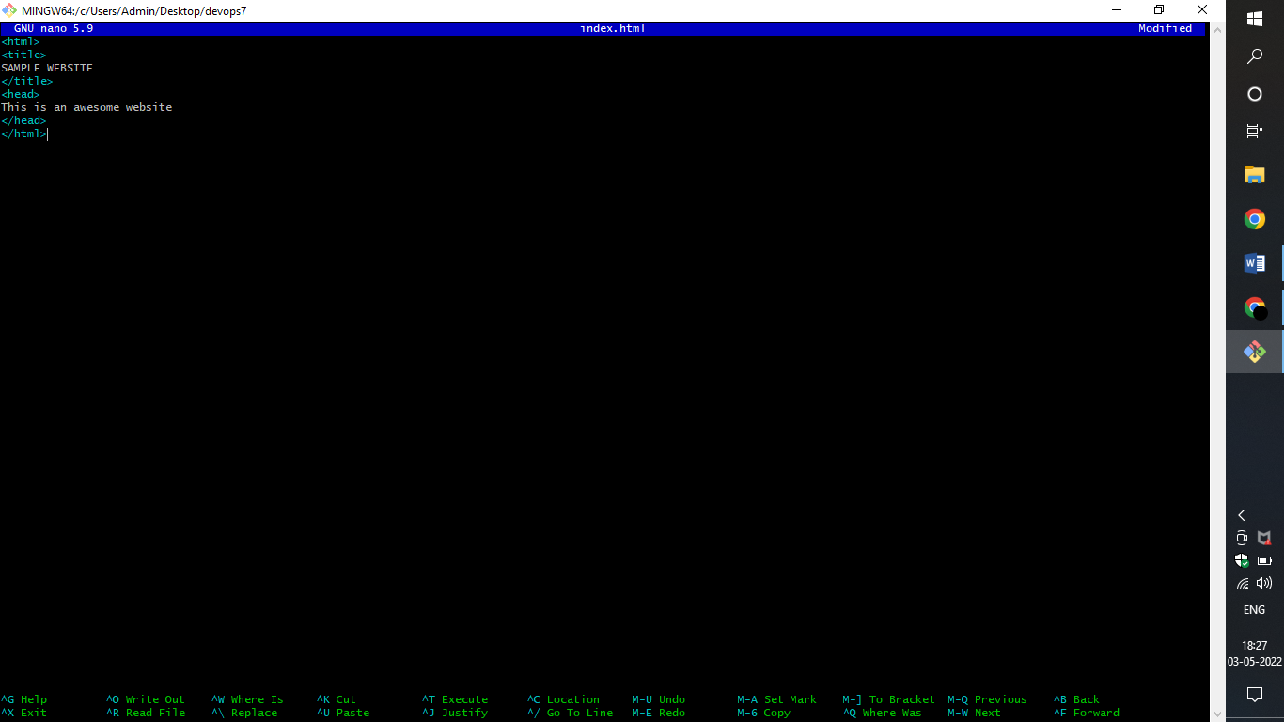

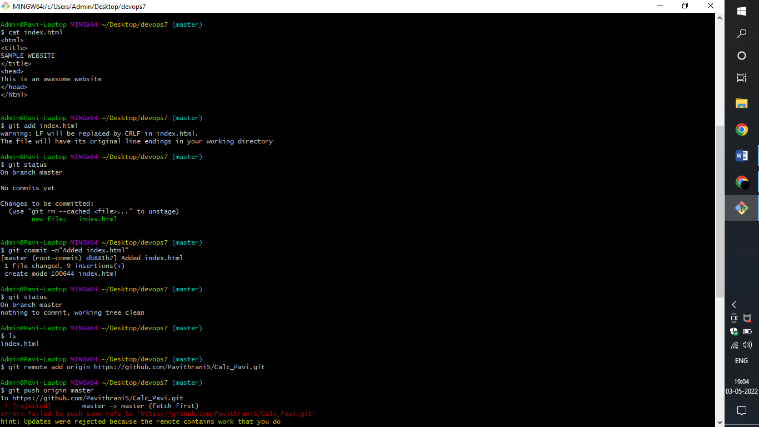

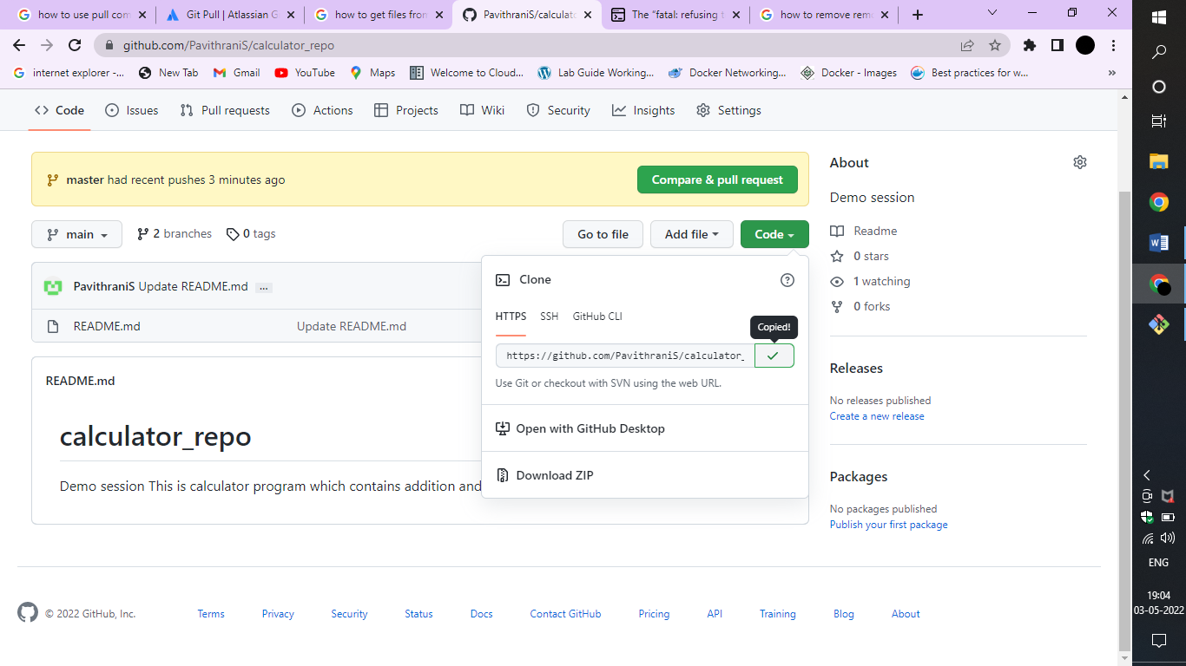

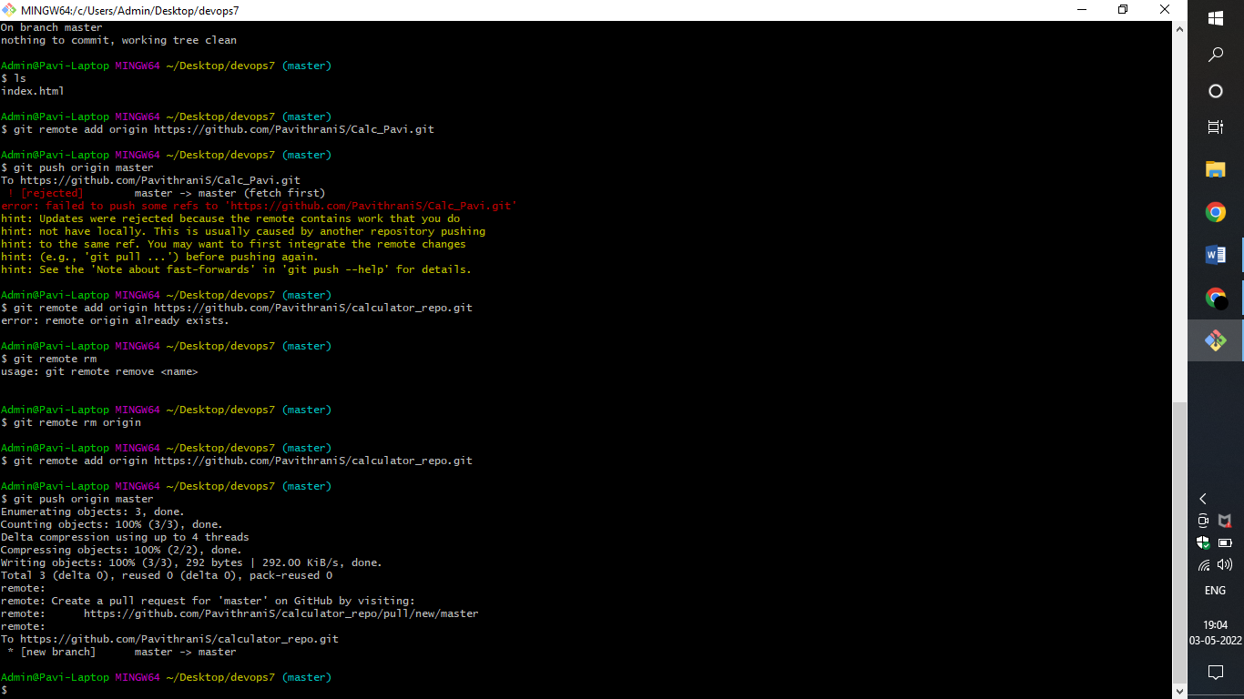

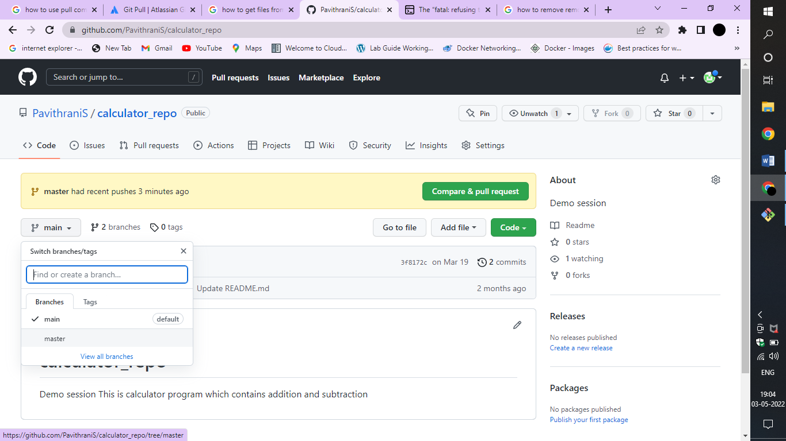

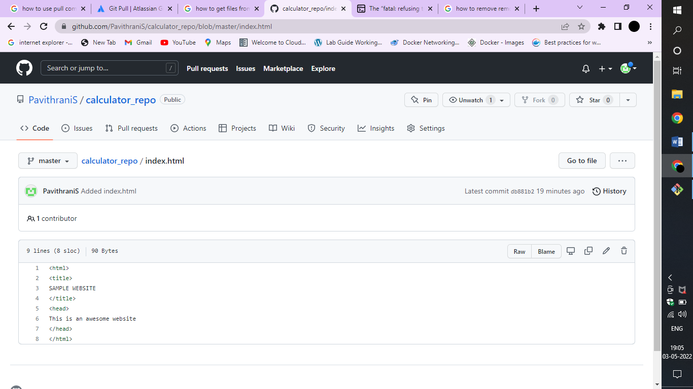

**RESULT:**

Hence a file is created and pushed from local to remote repository successfully.

**CREATE FIRST JOBS IN JENKINS**

**Aim:**

To create the first job in Jenkins and build it using simple windows batch commands.

**Algorithm:**

**Step 1:** Browse to ‘http://localhost:8080’ to unlock Jenkins.

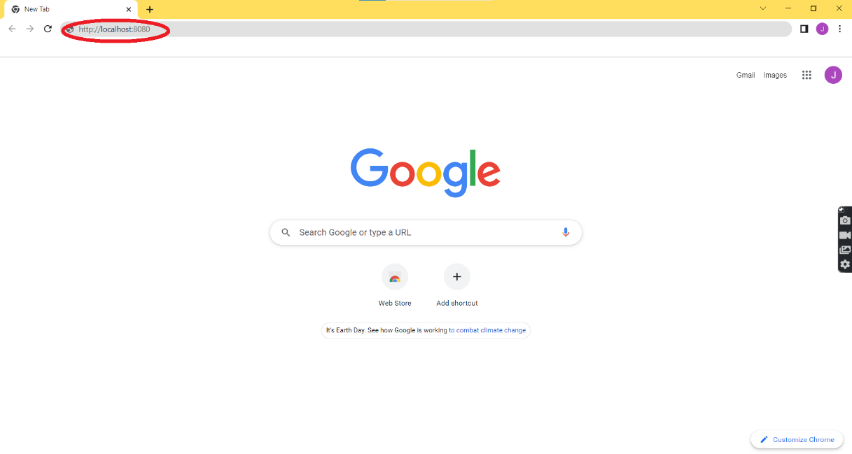

**Step 2:** Login to Jenkins using your login credentials.

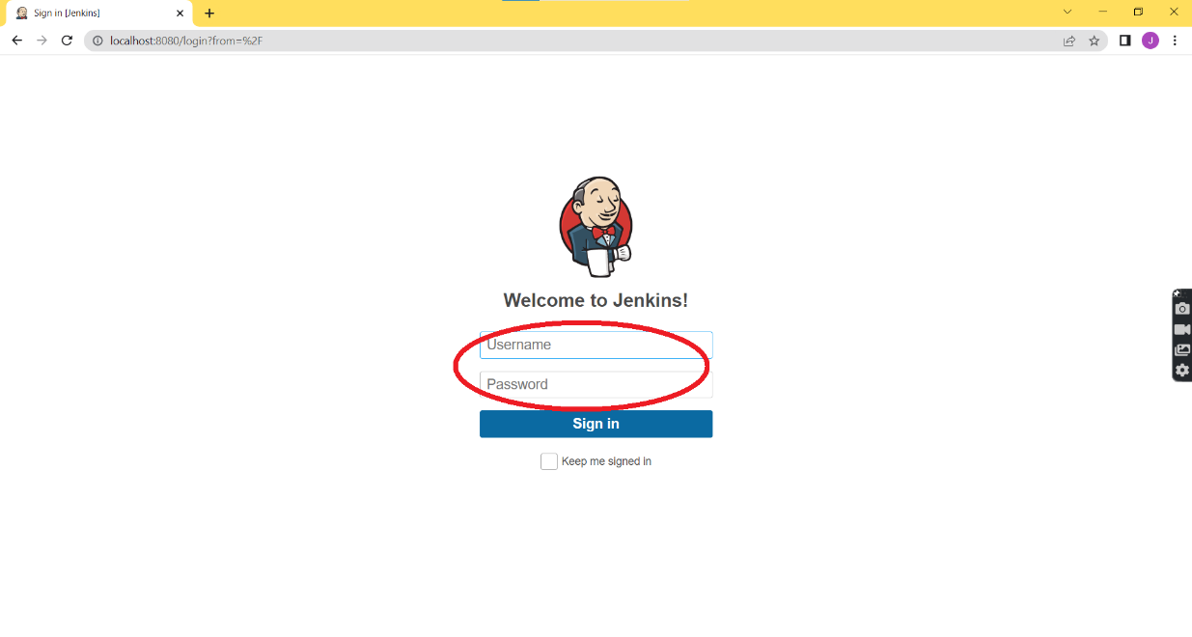

**Step 3:** Click on New Item in the Jenkins dashboard page to create a new job.

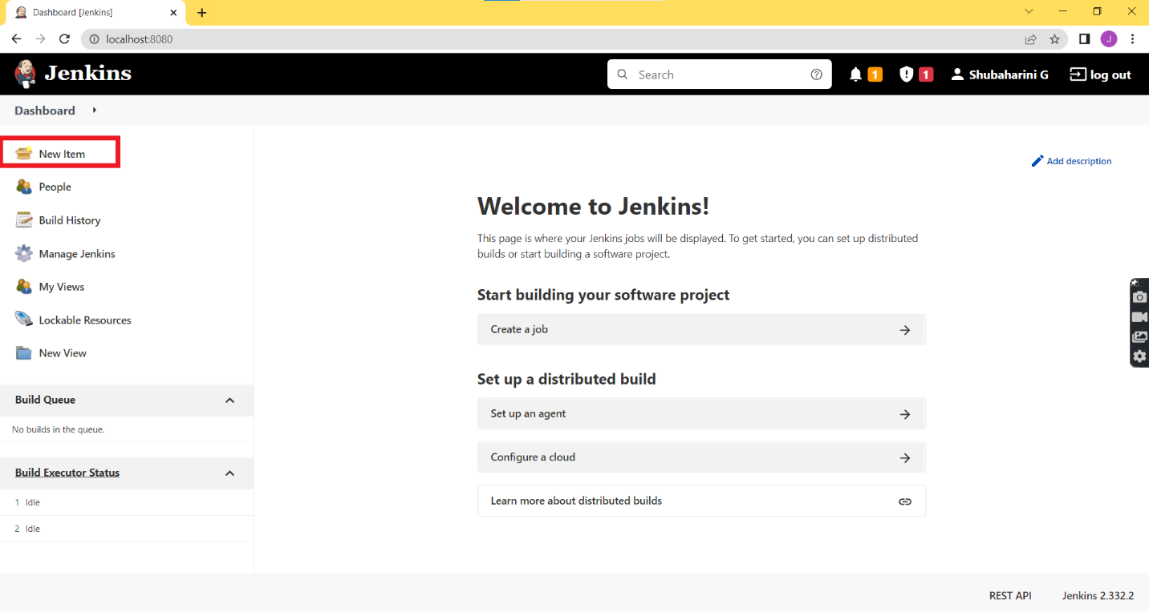

**Step 4:** Give a unique name for your project (job) in the ‘Enter an item name’ field.

**Step 5:** Select the job type as ‘Freestyle project’ listed below the project name field and Click Ok.

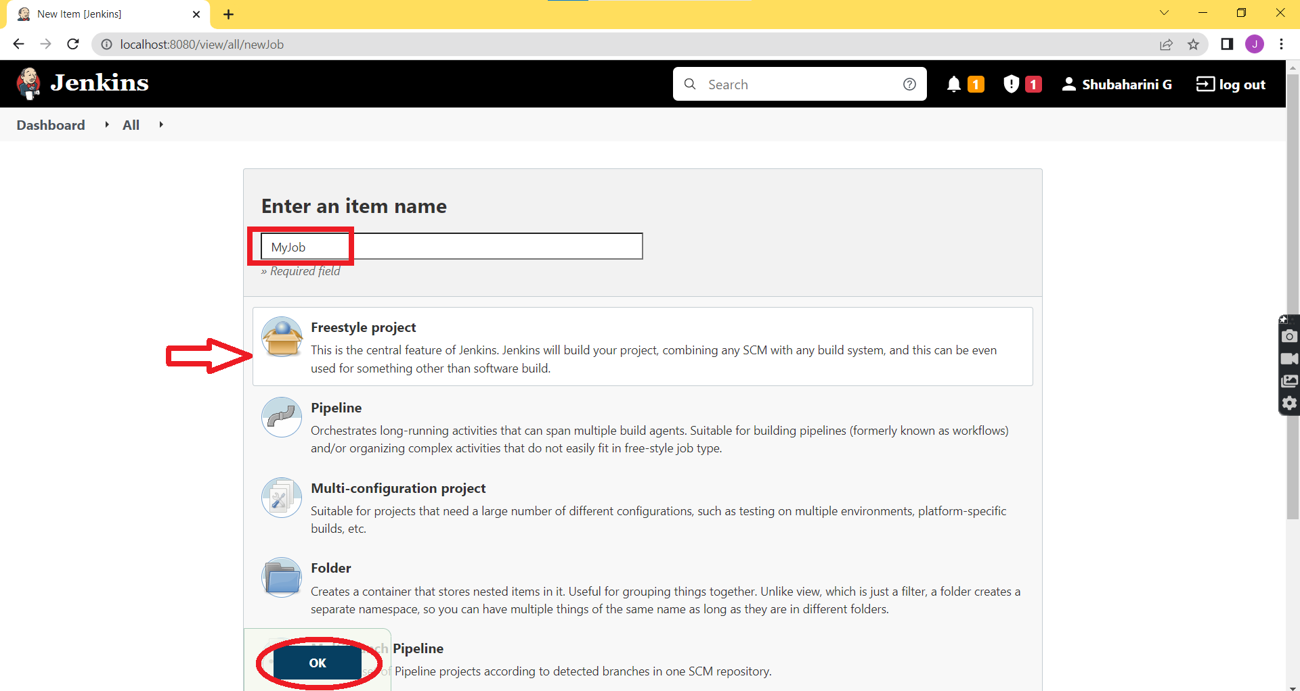

**Step 6:** In the General tab of the configuration page give the description of your project.

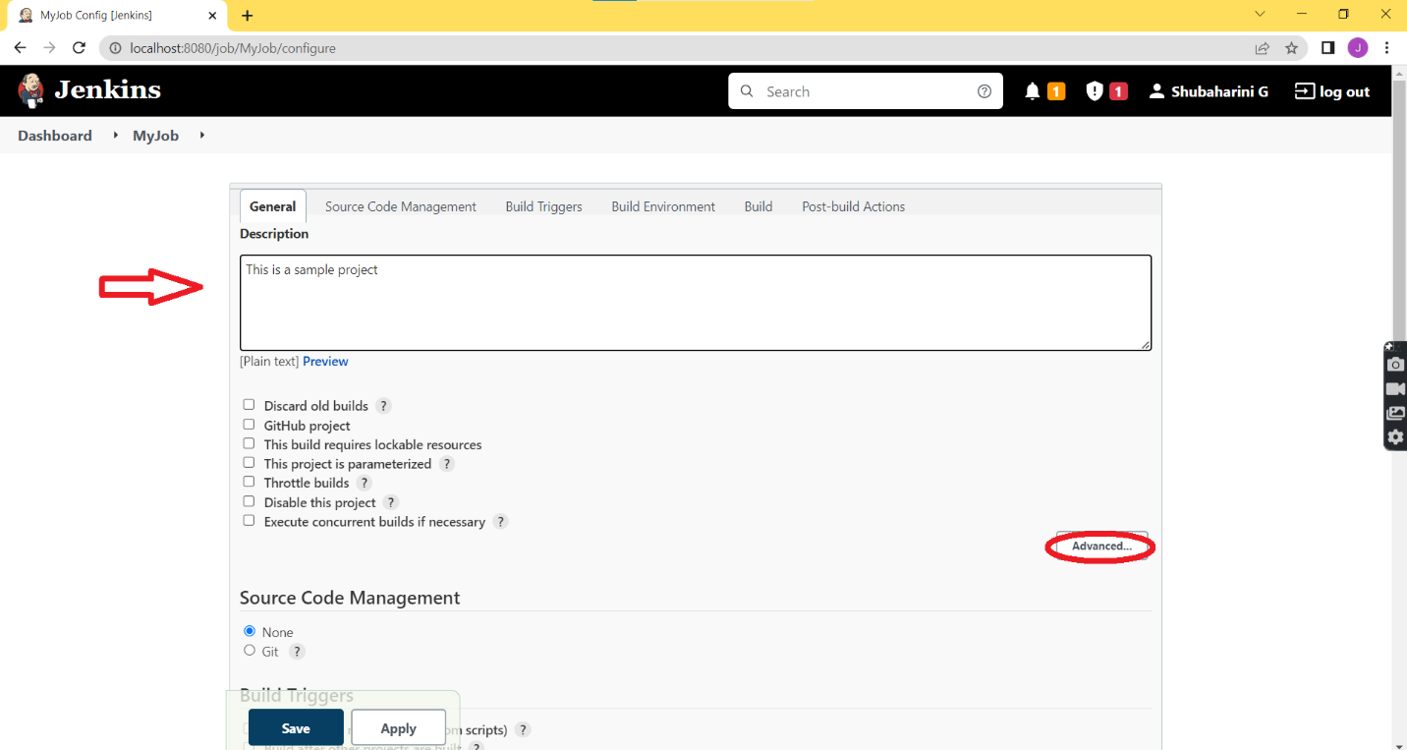

**Step 7:** Click on Advanced option to give optional display name that is to be shown for the project throughout the Jenkins web GUI.

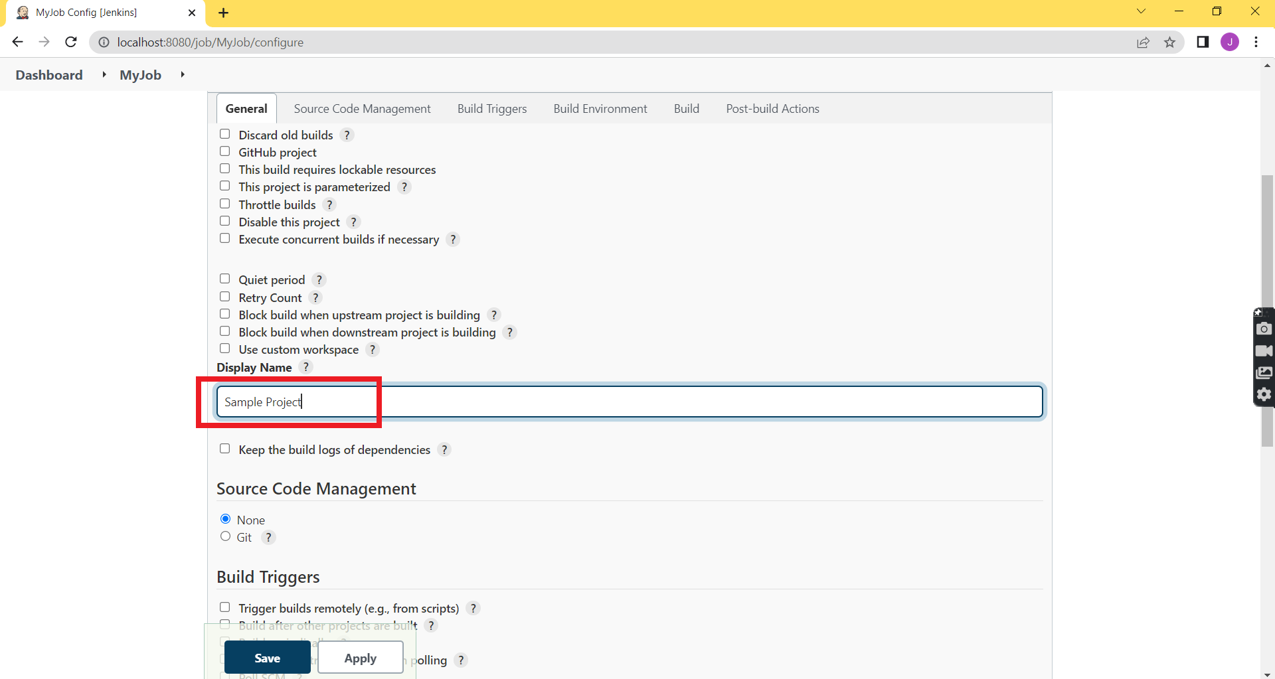

**Step 8:** Now move to the Build tab either by scrolling down or by clicking the options from the top and select Add build step option.

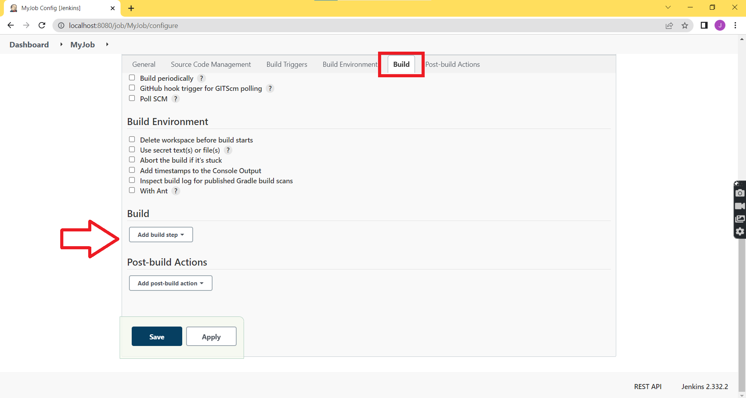

**Step 9:** In the Add build step option choose ‘Execute Windows batch command’ to run a windows batch script for building a project.

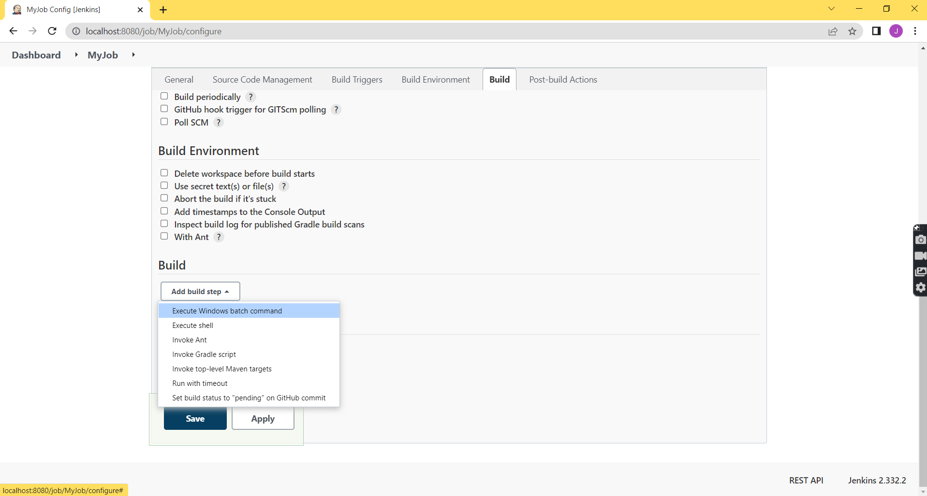

**Step 10:** We will build the job by checking the java version in the local system and by the printing “Hello” text using the following commands:

To check Java version: java -version

To print the statements: echo “Hello! Welcome to Jenkins”

**Step 11:** Now Click Apply and then Click Save.

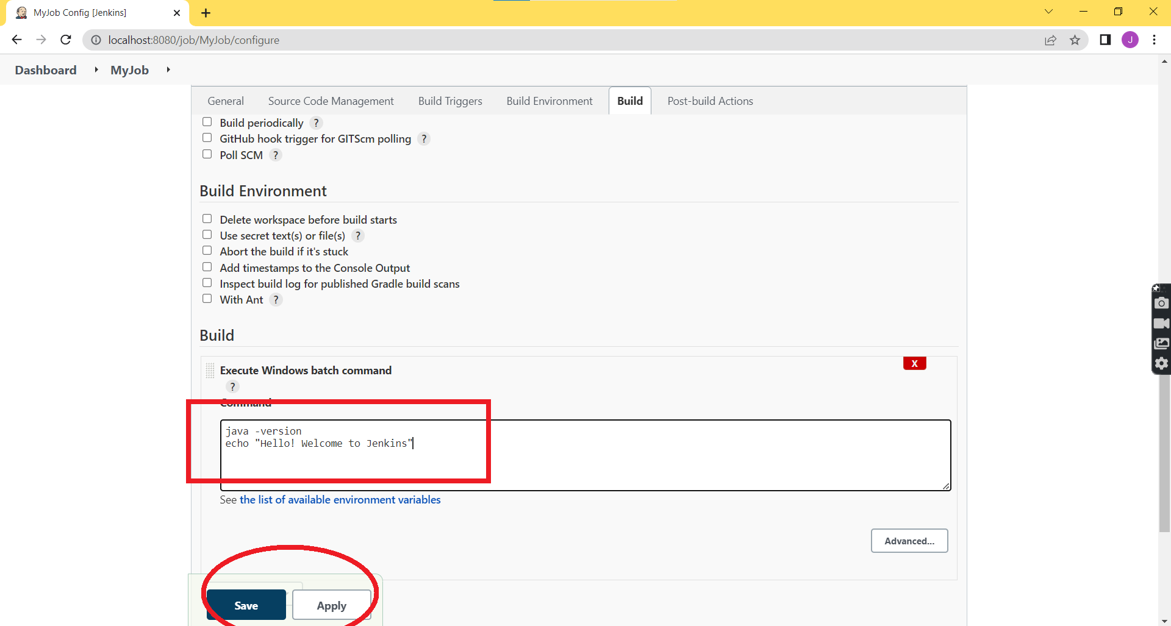

**Step 12:** The created project will appear in the workspace with the given Project name, Display name and Description.

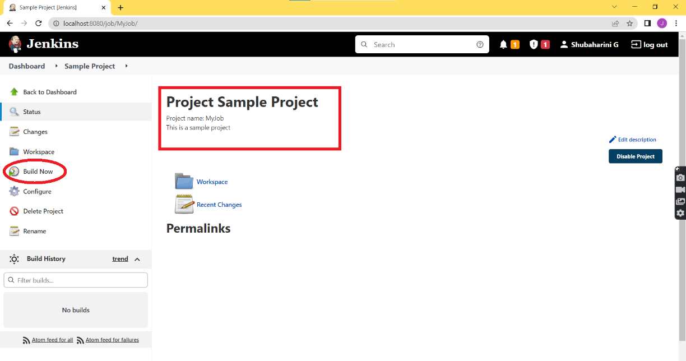**Step 13:** To build the project select on ‘Build Now’ option which is displayed to left of workspace.

**Step 14:** You will find the completed build run below the ‘Build History’ in the left, the first build is indicated as ‘#1’.

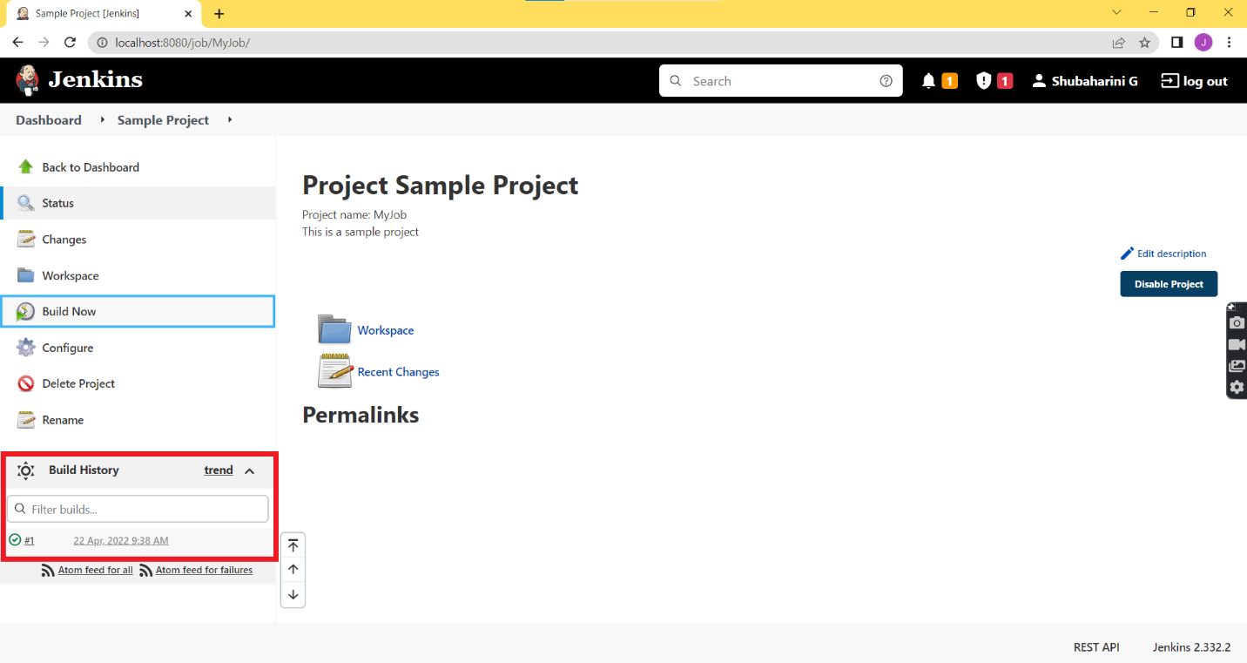

**Step 15:** Click on the ‘#1’ and Select ‘Console Output’.

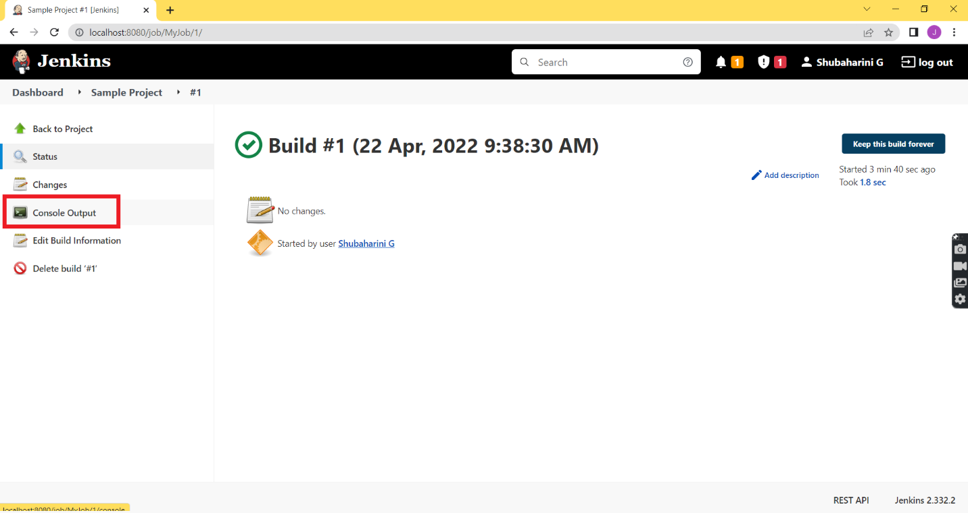

**Step 16:** The Console output displays whether the build is successful or not.

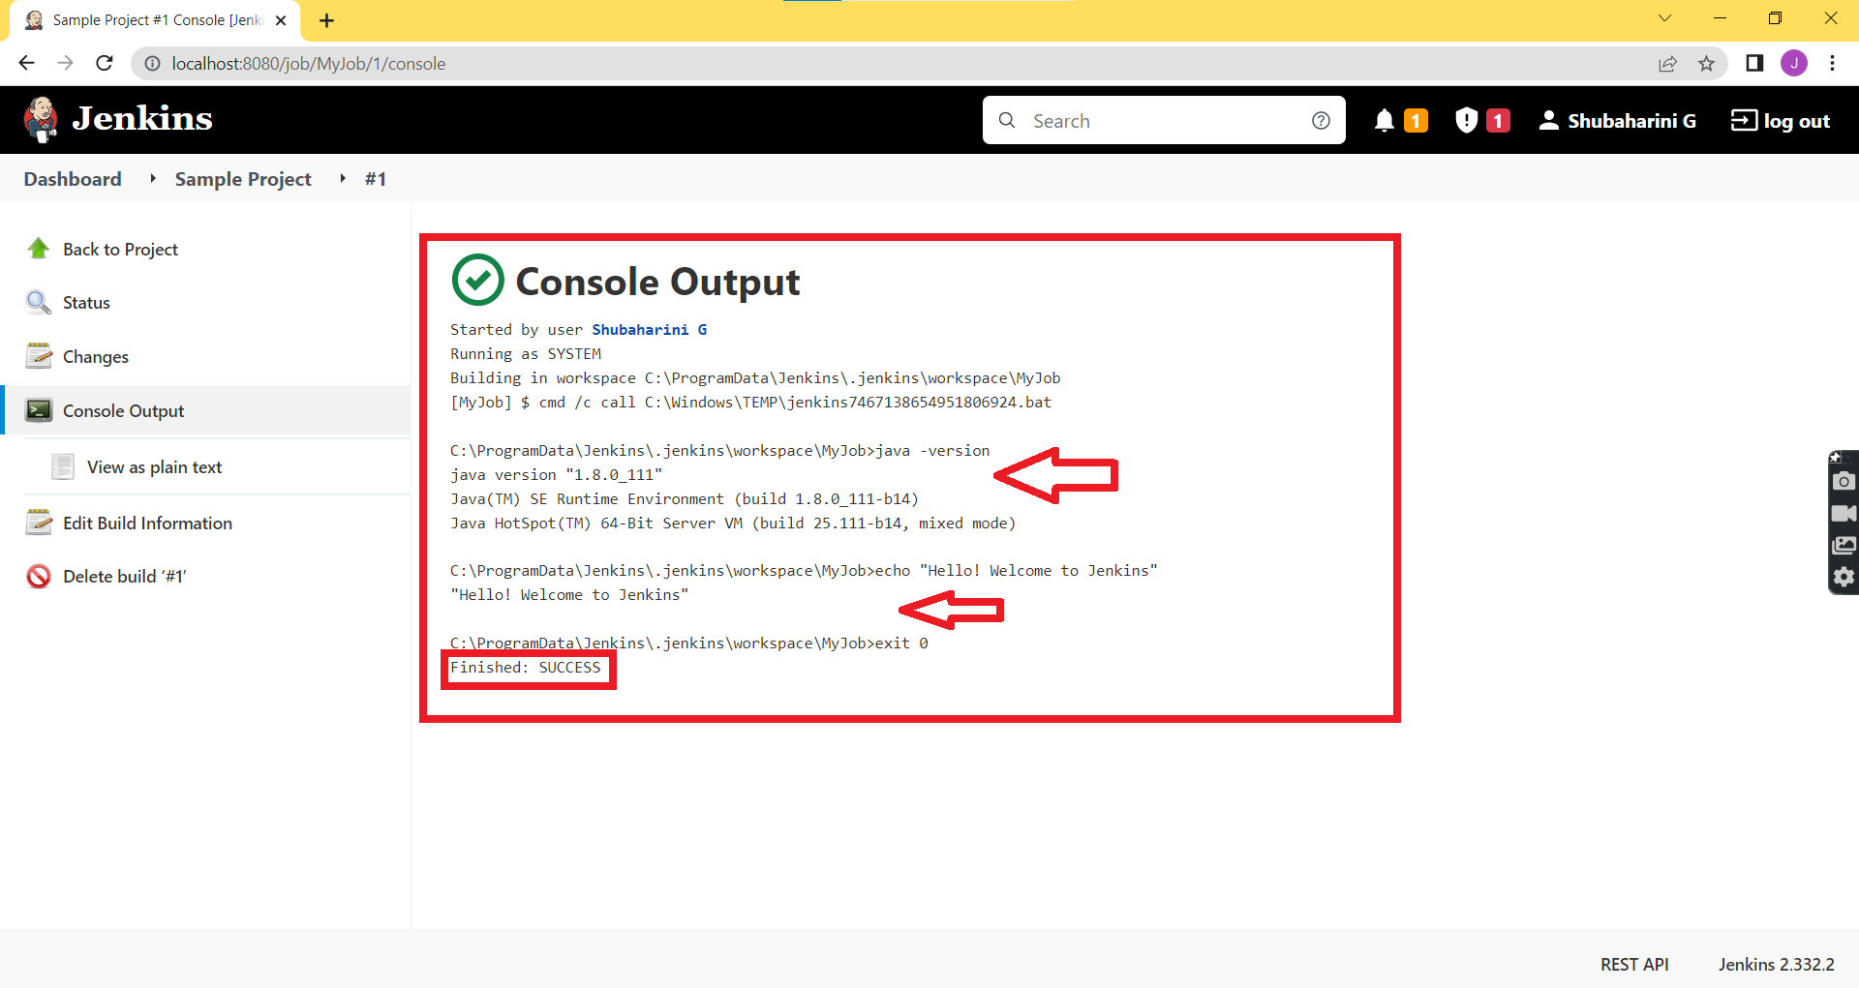

**Result:**

The job has been created and built using Build tab. Hence, the output is obtained successfully and the result is displayed.

**CONFIGURE EMAIL NOTIFICATIONS IN JENKINS**

**Aim:**

To configure email notifications in Jenkins using the mail plugins.

**Algorithm:**

**Step 1:** Open the Chrome browser, Select your profile and click on ‘Manage your Google Account’.

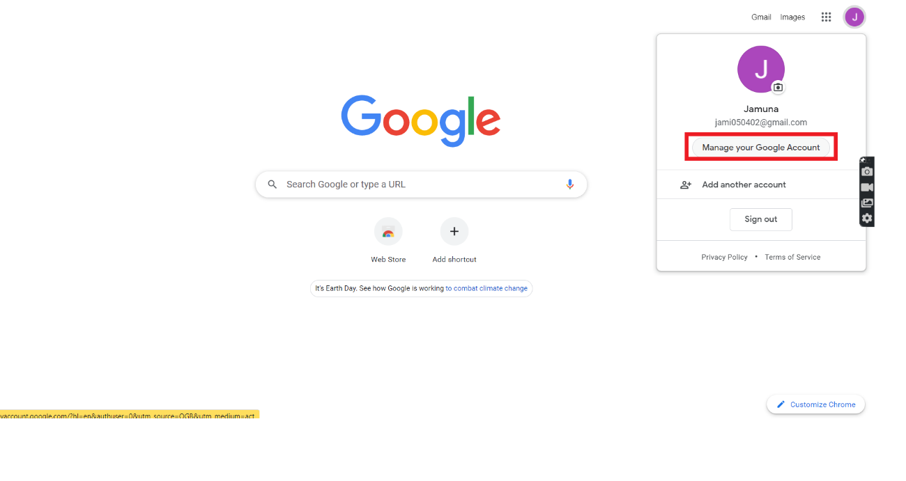

**Step 2:** In the my accounts page select ‘Security’ and Scroll down to Click on ‘App passwords’ for generating passwords.

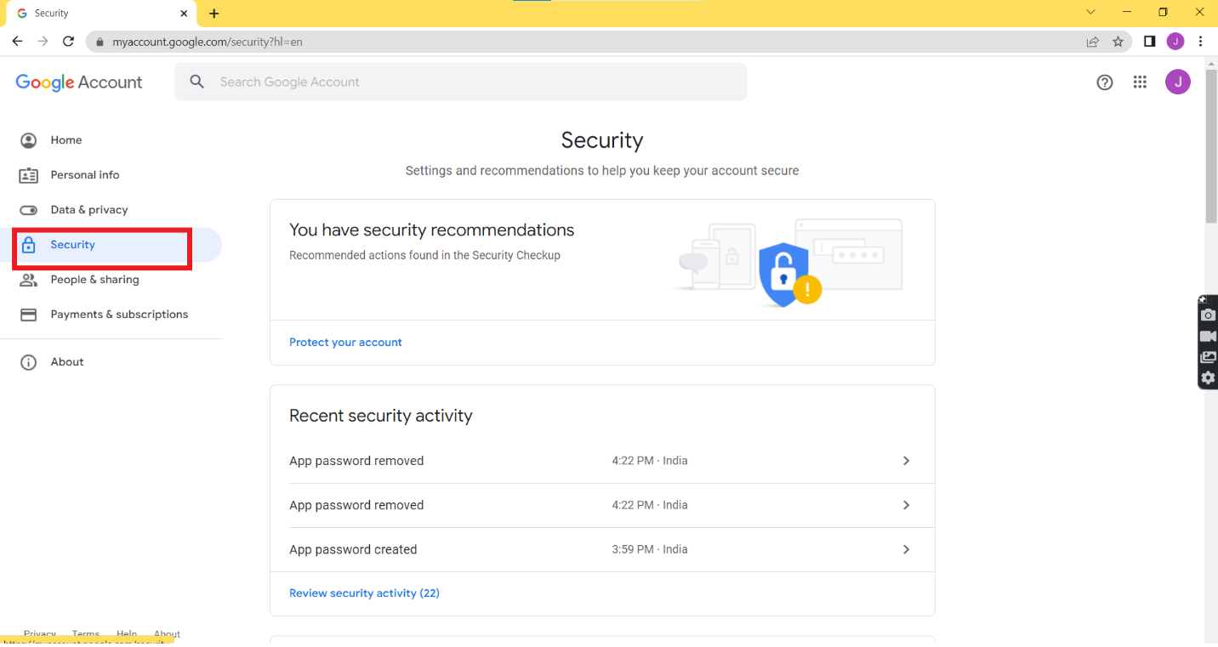

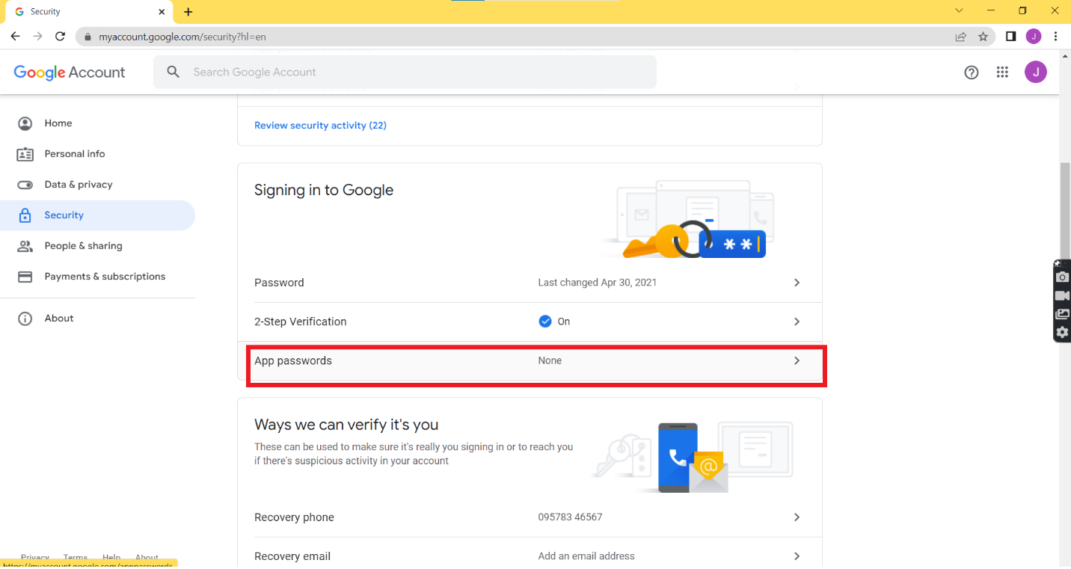

**Step 3:** Now give your Gmail account password and select next.

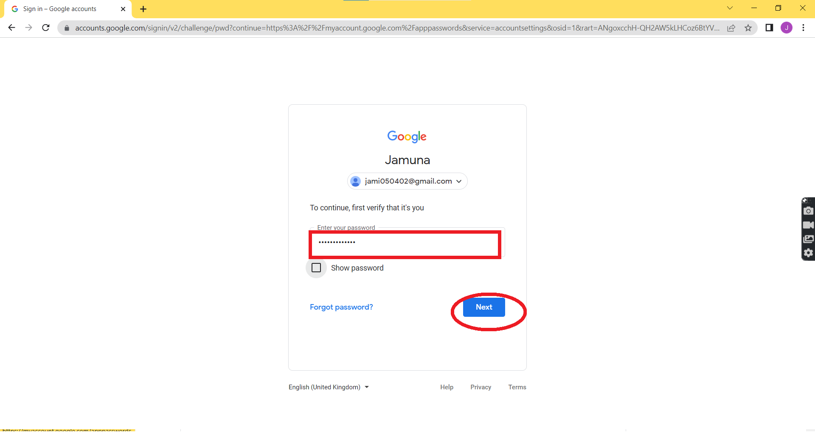

**Step 4:** In the App passwords console, select the app and device for password generation and then Click on Generate.

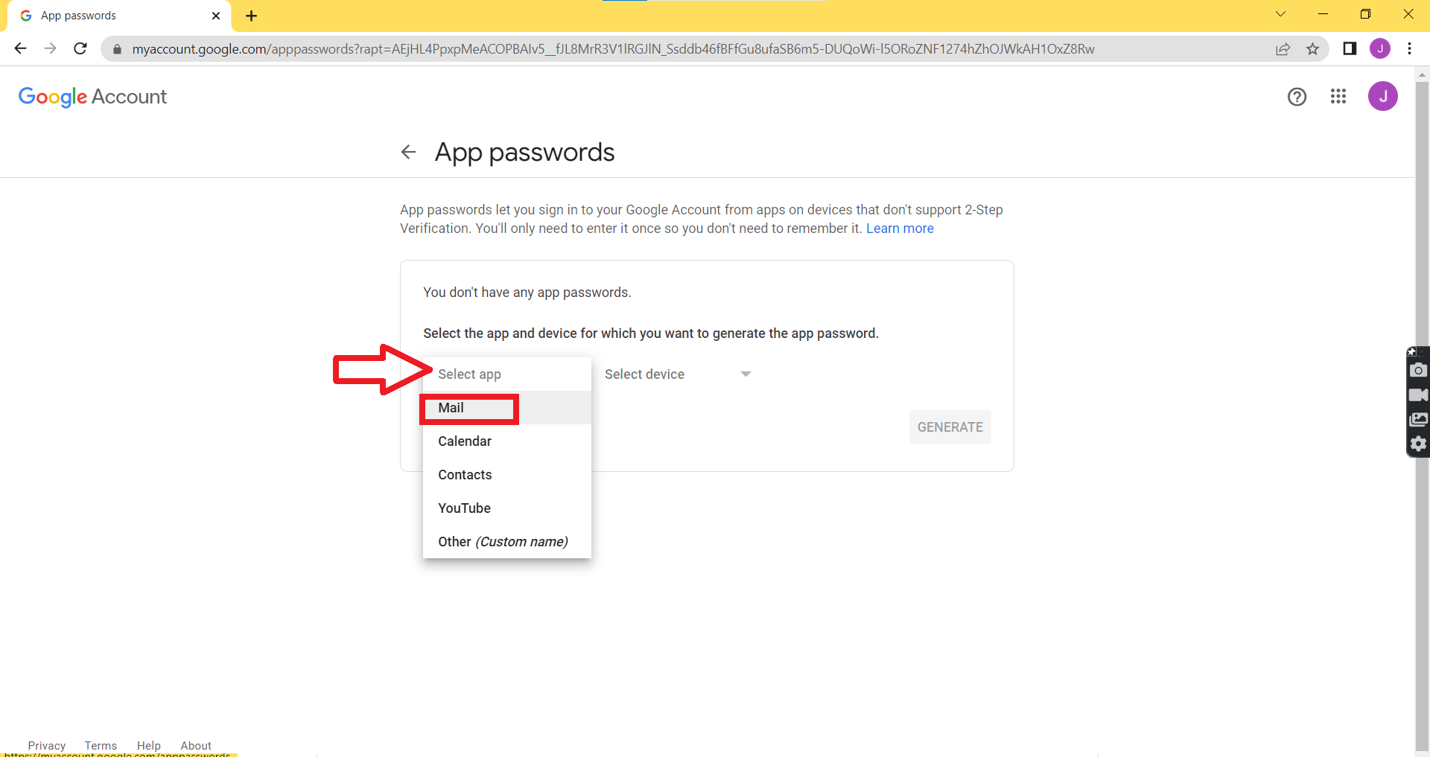

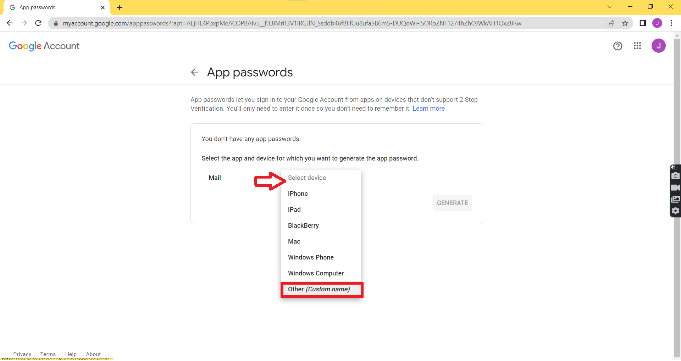

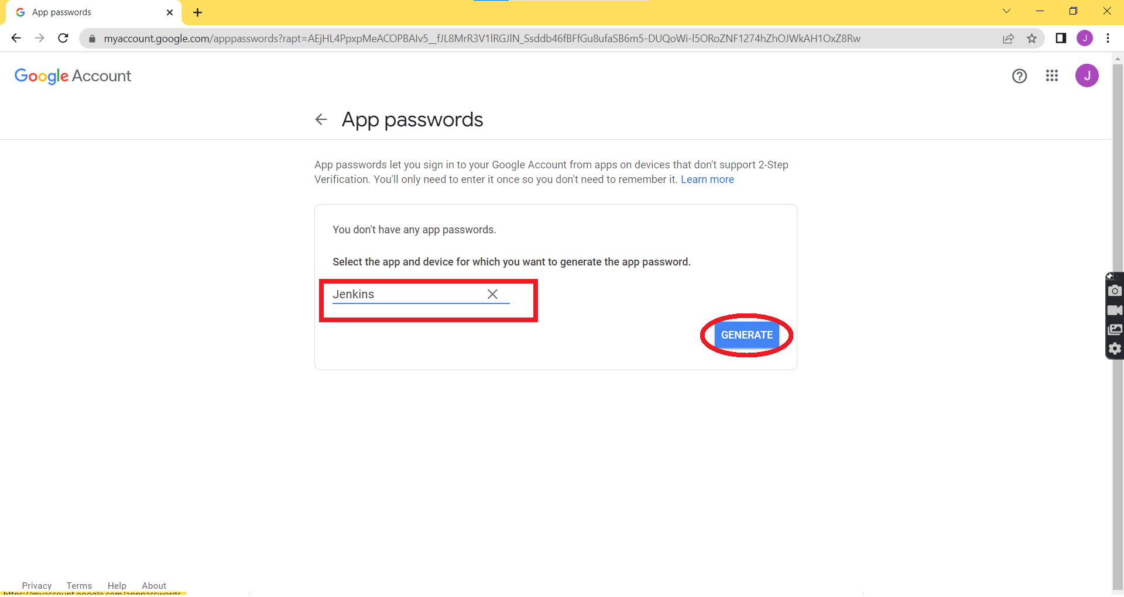

**Step 5:** Copy the Generated App Password and select done.

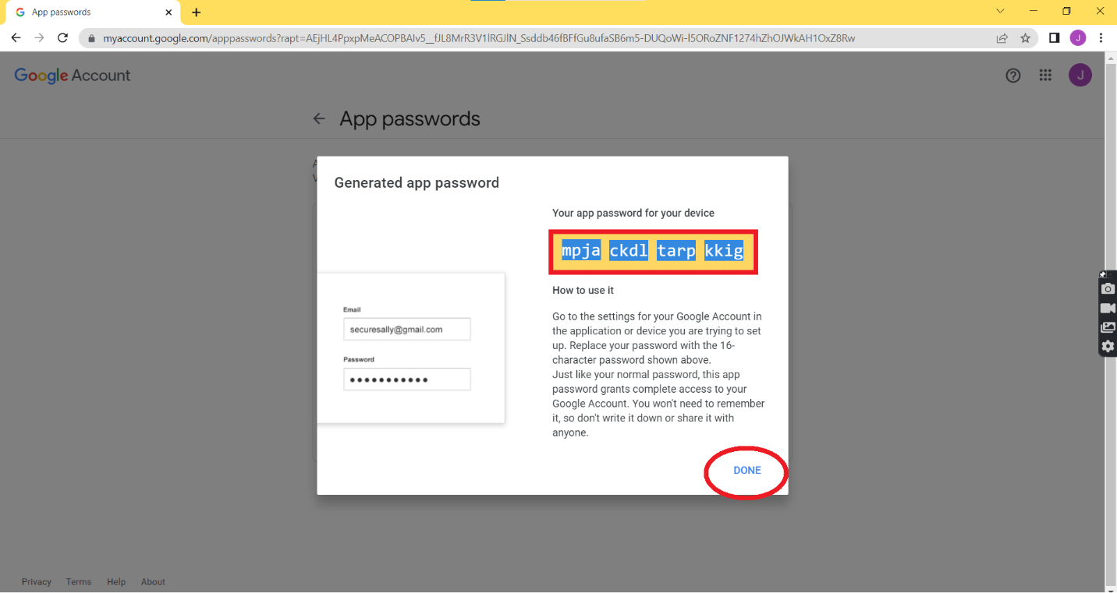

**Step 6:** Now browse to ‘http://localhost:8080’ to unlock Jenkins.

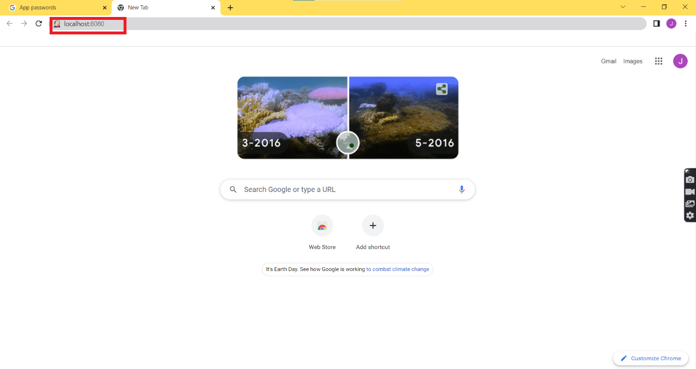

**Step 7:** Login to Jenkins using your login credentials.

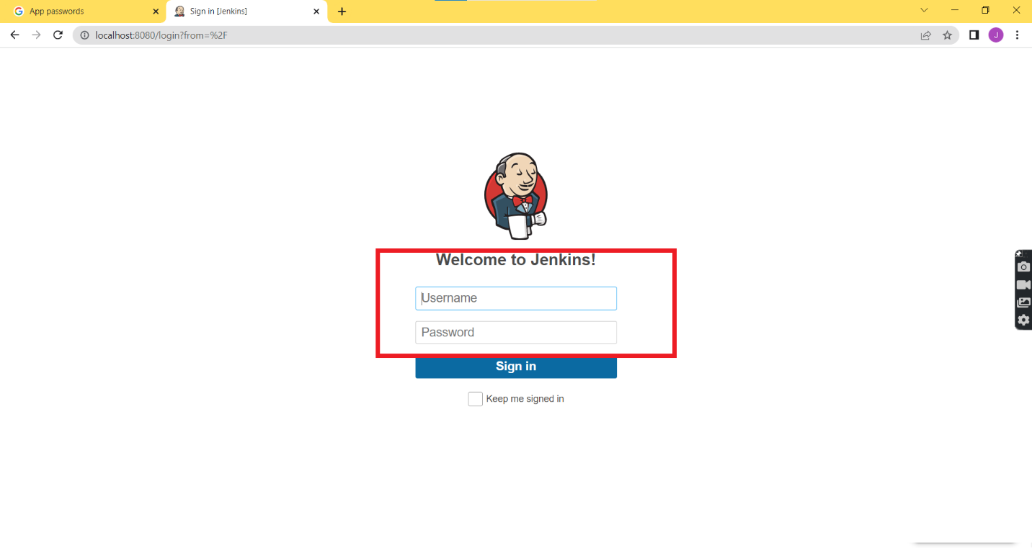

**Step 8:** In the Jenkins Dashboard, Select on ‘Manage Jenkins’ and then Click ‘Configure System’ in the system configuration.

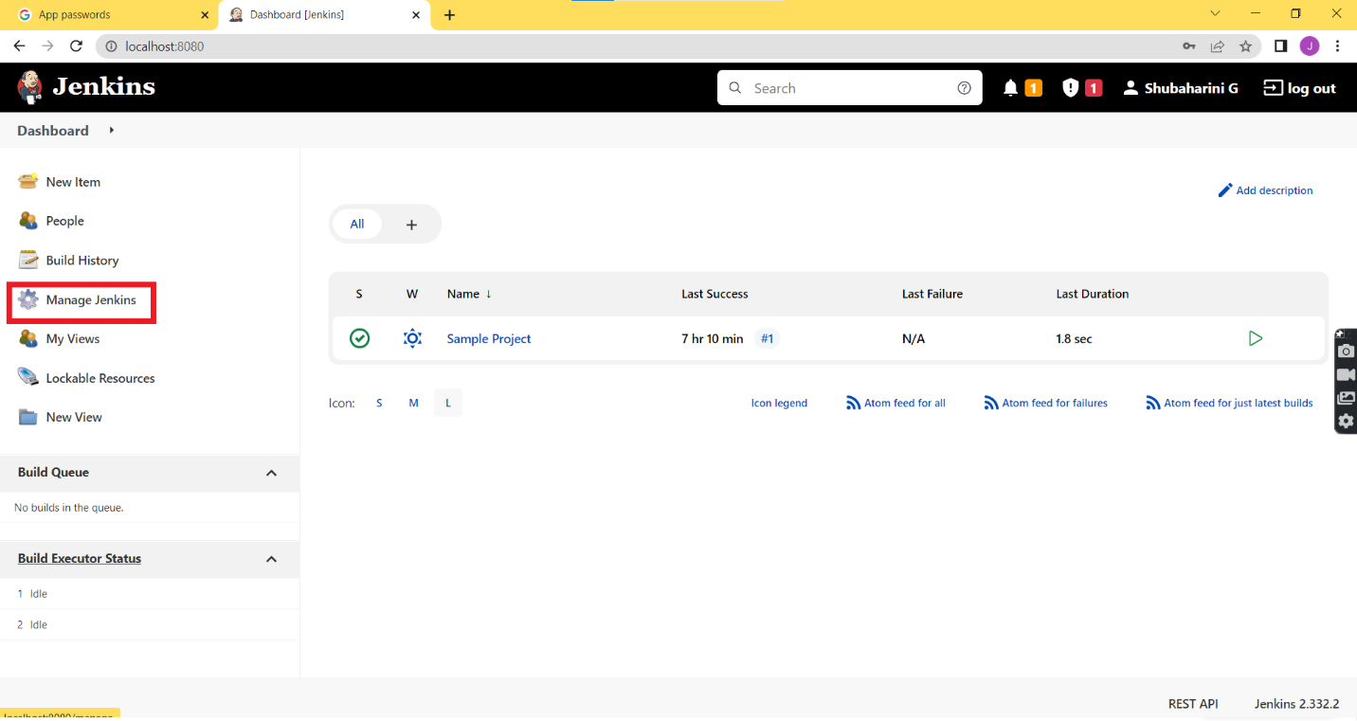

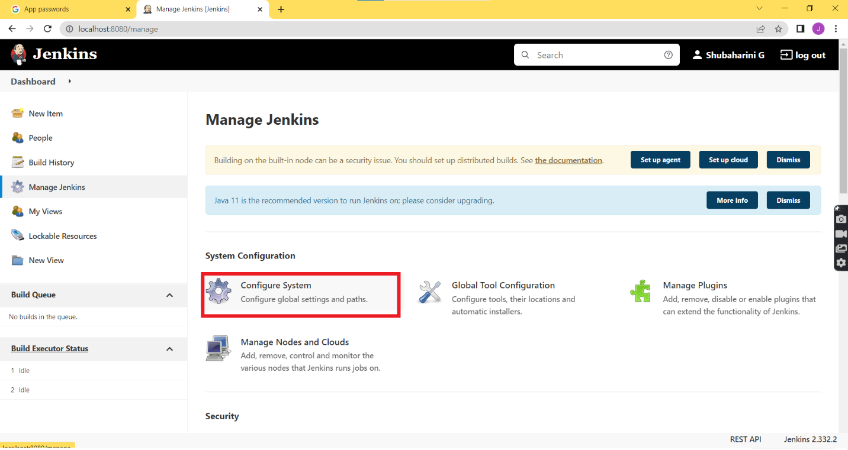

**Step 9:** Scroll down to Extended Email Notification and give ‘smtp.gmail.com’ in the SMTP server field and in the SMTP port field enter ‘465’ then Click on Advanced.

**Step 10:** Leave the Credentials field default and then select ‘Use SSL’.

**Step 11:** Then skip the ‘Advanced Email Properties’ and move to the ‘Default user e-mail suffix’ field and enter the email suffix as ‘@gmail.com’.

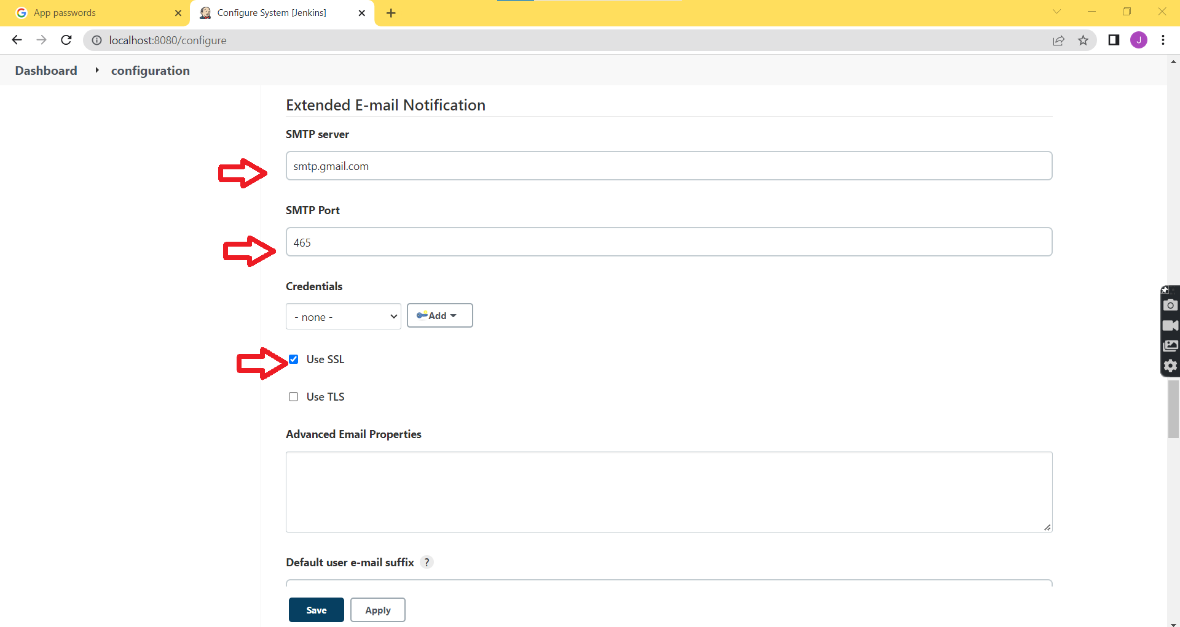

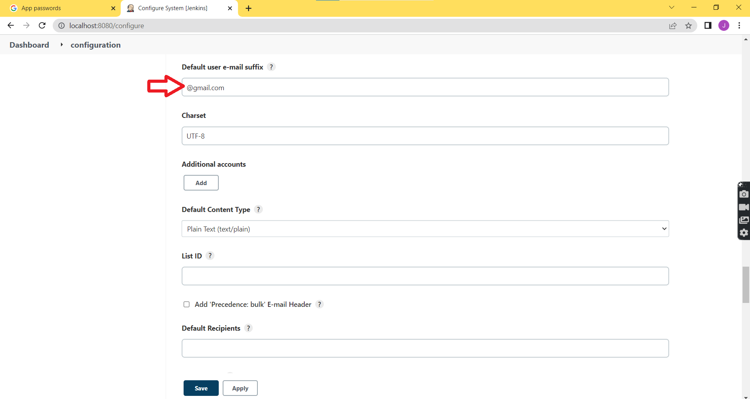

**Step 11:** Leave the other fields empty and scroll down to ‘Additional groovy ‘classpath’ check on ‘Enable debug mode’. Click on ‘Default Triggers’.

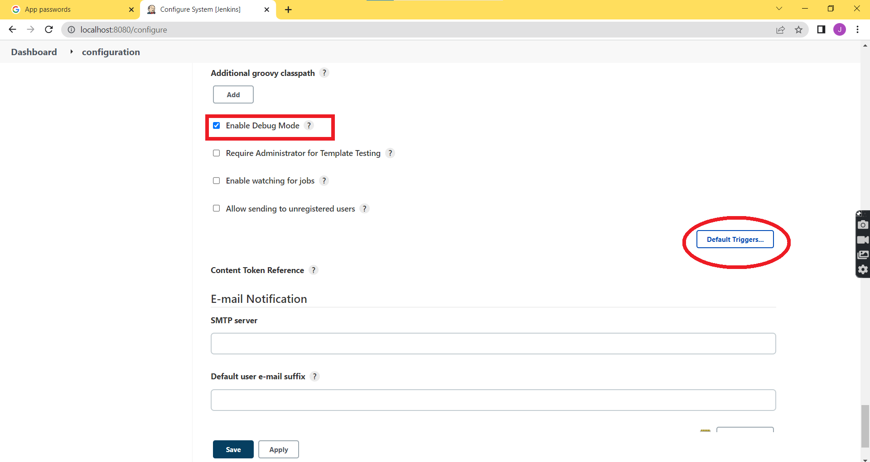

**Step 12:** Check on ‘Always’ in the below listed check boxes and then move to Email notification.

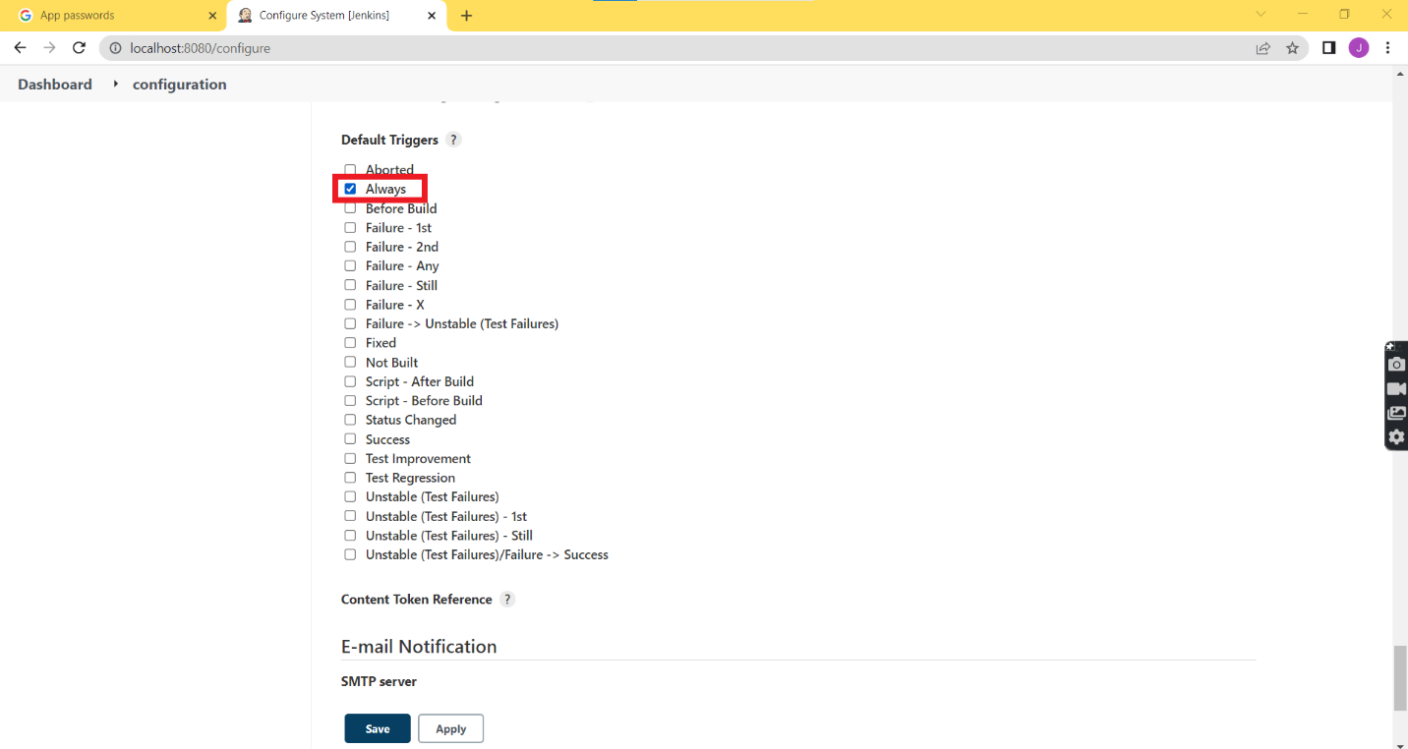

**Step 13:** Again in the SMTP server field enter ‘smtp.gmail.com’ and in the Default user e-mail suffix field enter ‘@gmail.com’. Then Click on Advanced.

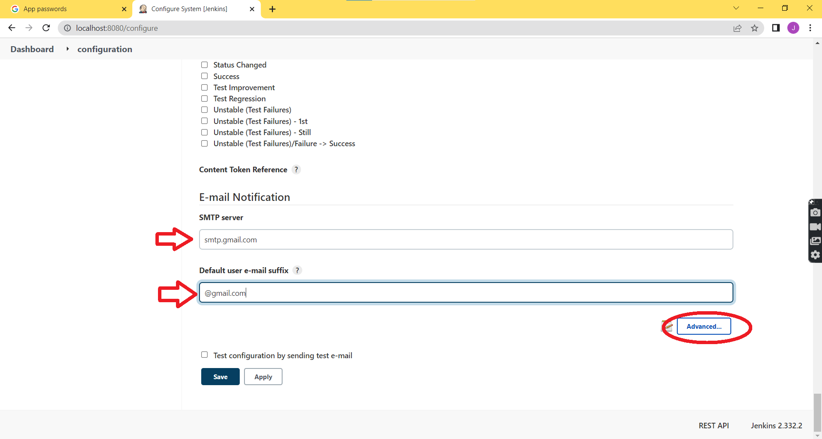

**Step 14:** Check on the ‘Use SMTP Authentication’ and enter your Gmail id and password in the ‘Username and Password’ fields.

**Step 15:** Now Check on ‘Use SSL’ field and enter the SMTP port as ‘465’.

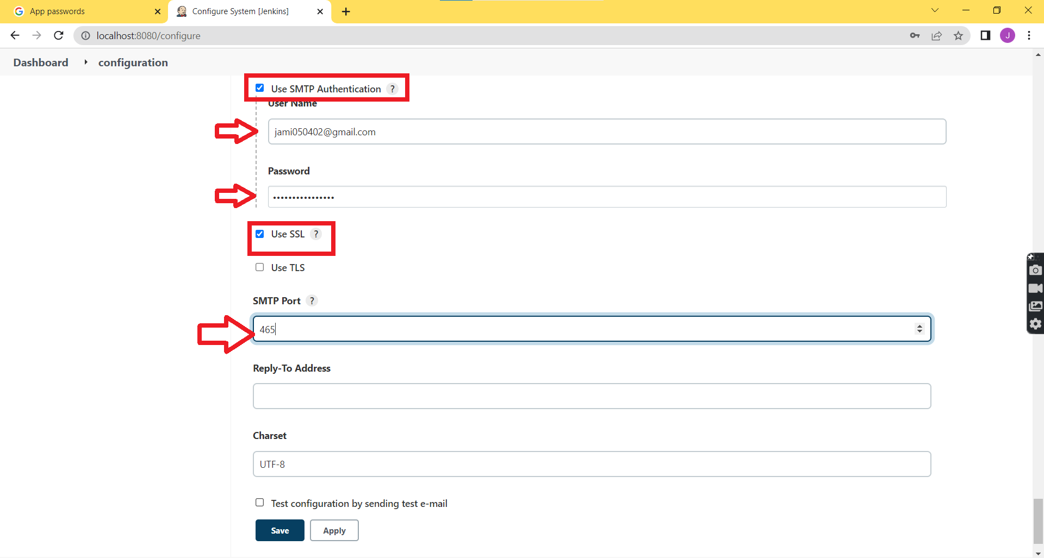

**Step 16:** Check on the ‘Test configuration by sending test e-mail’ field under the ‘Test e-mail recipient’ enter your mail id and then Click on ‘Test configuration’.

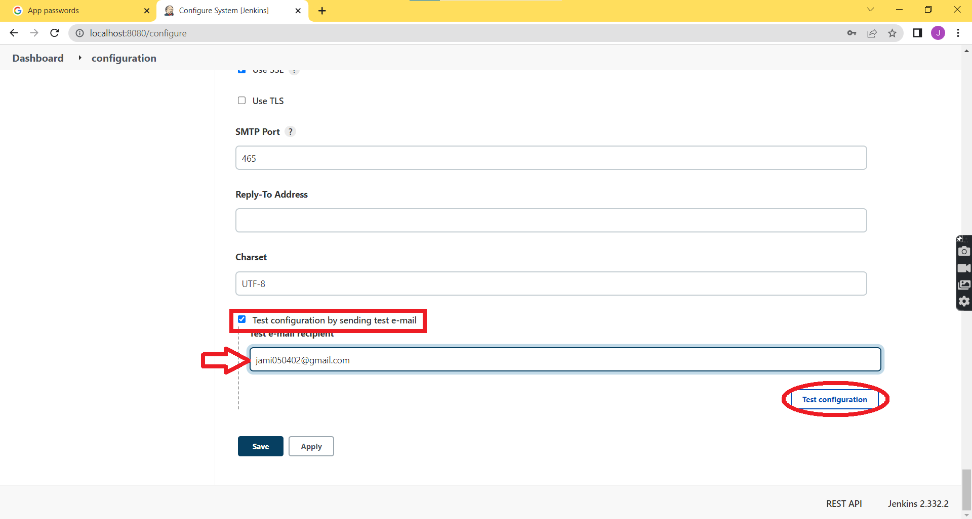

**Step 17:** You will see a notification as ‘Email was successfully sent’. Now Click Apply and then Click Save.

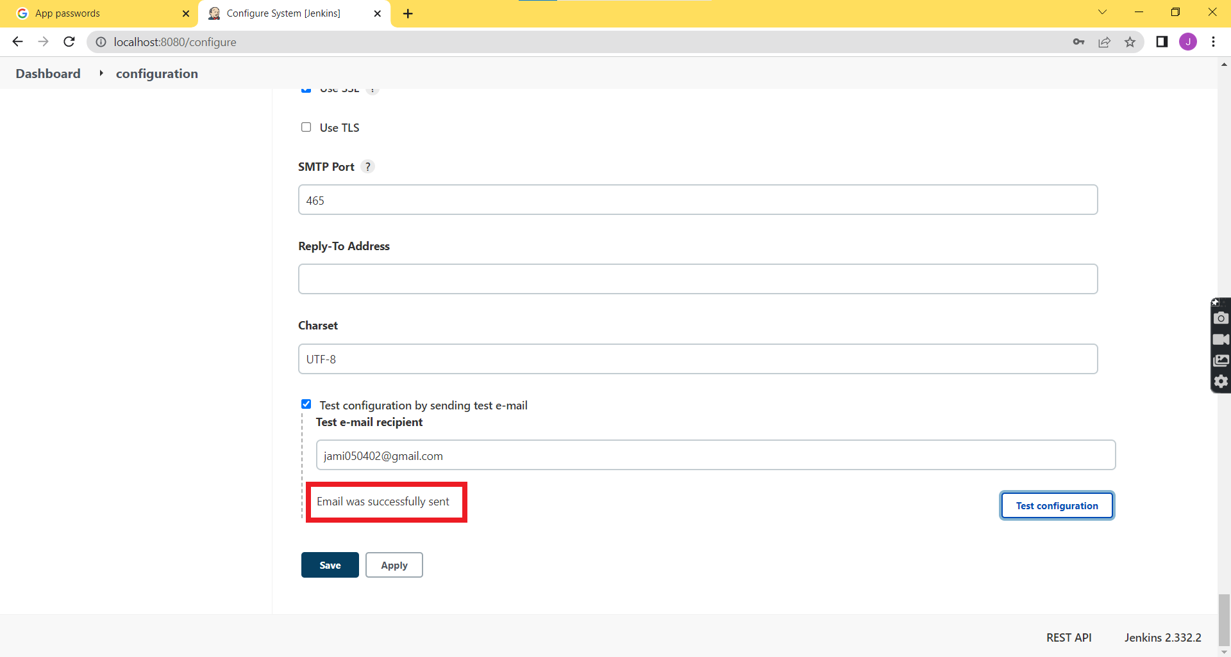

**Step 18:** In order to view the sample test email open your mail inbox.

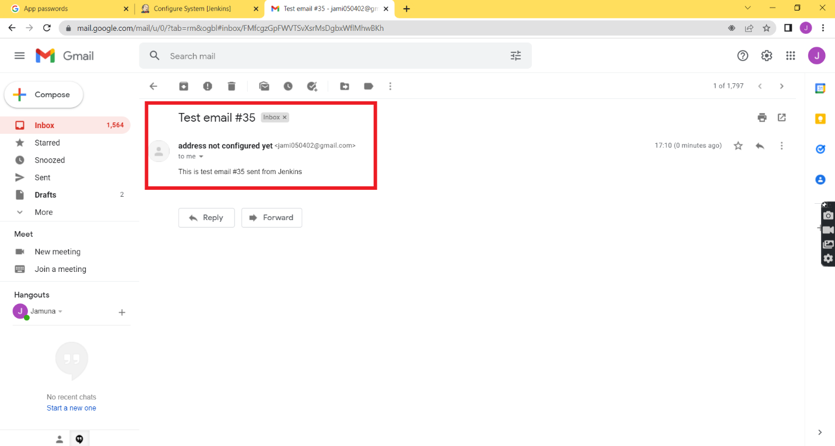

**Result:**

Thus the email notification configuration has been completed, and the email has been successfully delivered.

**BUILDING JAR FILE USING MAVEN**

**AIM:**

To build the jar file using maven in eclipse

**ALGORITHM:**

**Step 1:** In eclipse to create a new java project click File -> New -> Java Project.

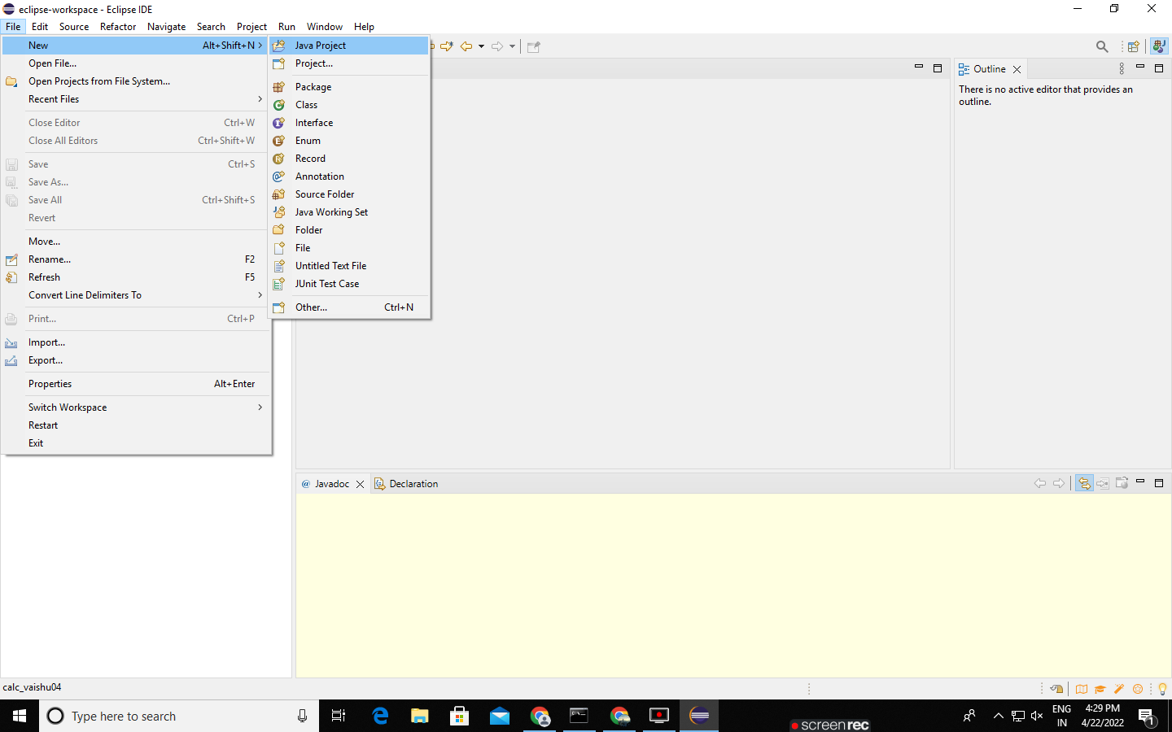

**Step 2:** Create a Java Project name calc_psgr and click Finish.

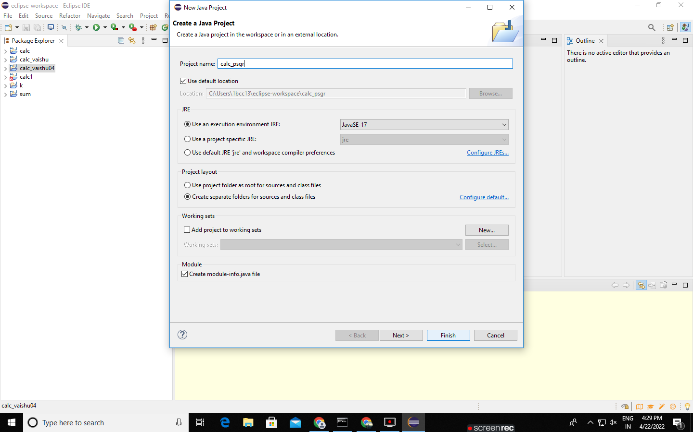

**Step 3:** In New module-info.java dialog box, click Create.

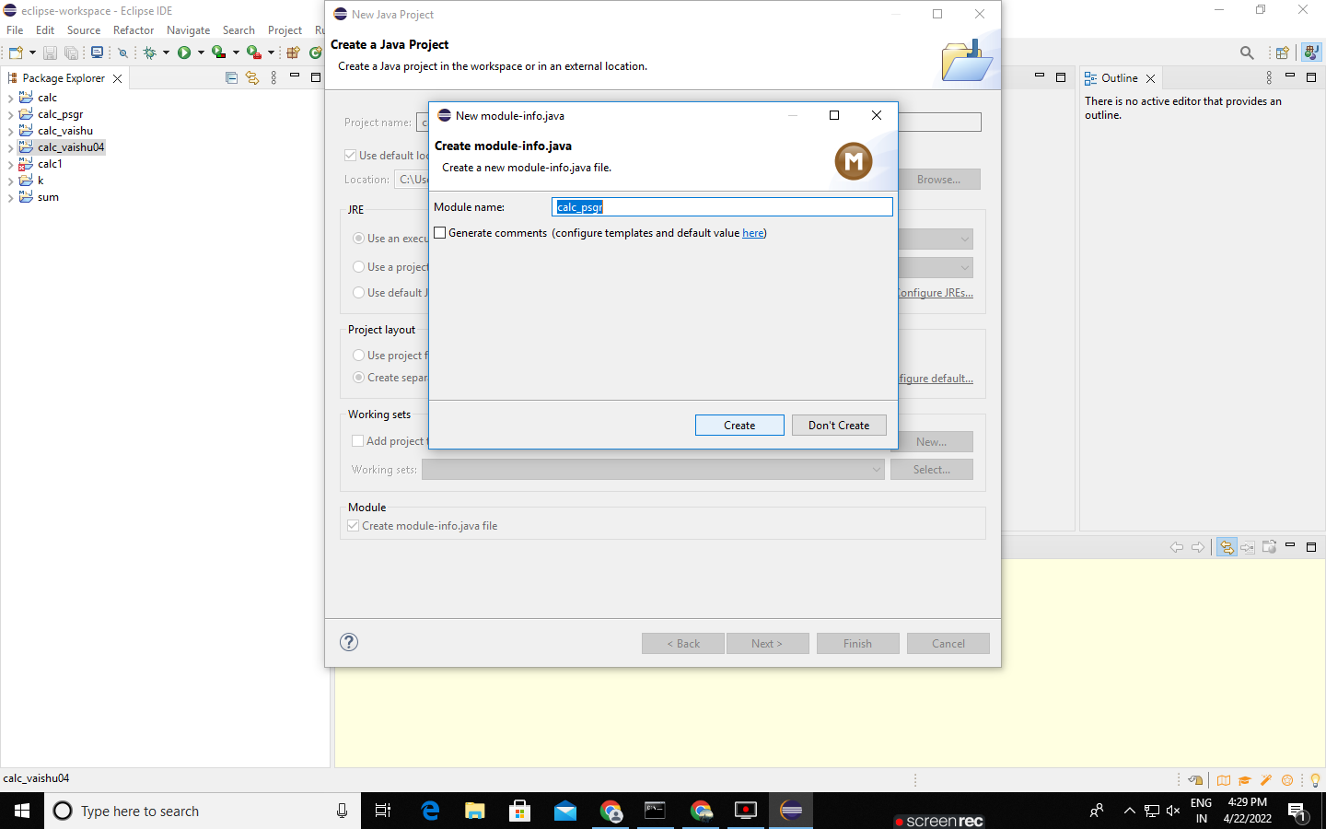

**Step 4:** To create a new java class select calc_psgr -> New -> Class

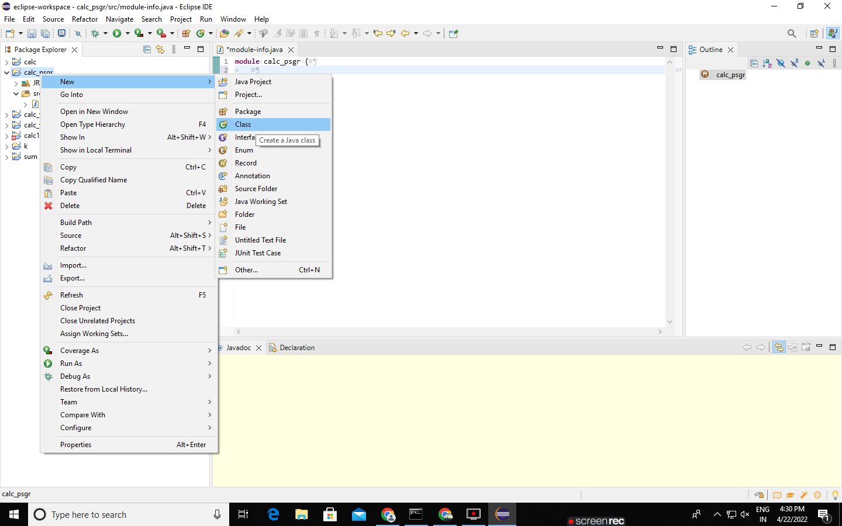

**Step 5:** In New Java Class dialog box give the class name as ‘Add’ and Click Finish.

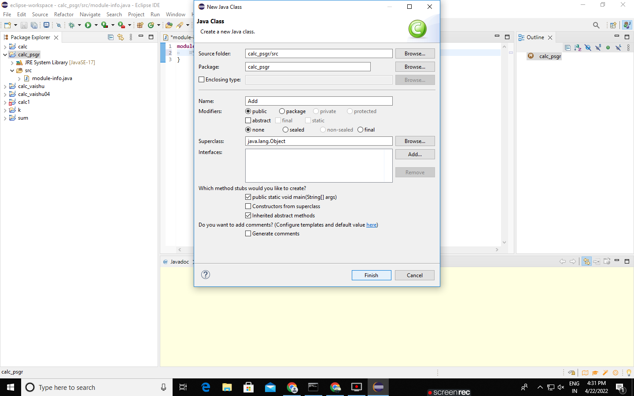

**Step 6:** Type simple addition java program and run it

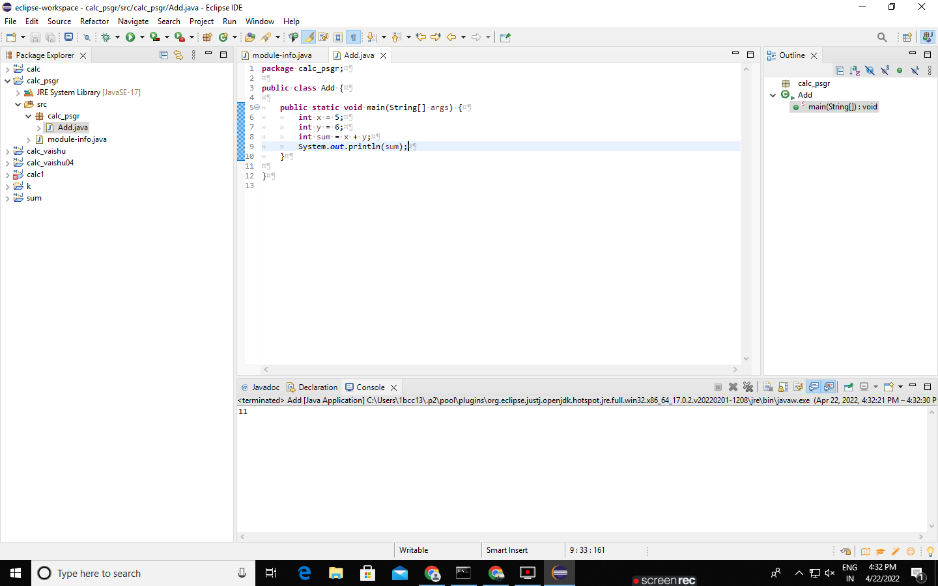

**Step 7:** To convert into Maven project, select calc_psgr -> Configure -> Convert to Maven Project.

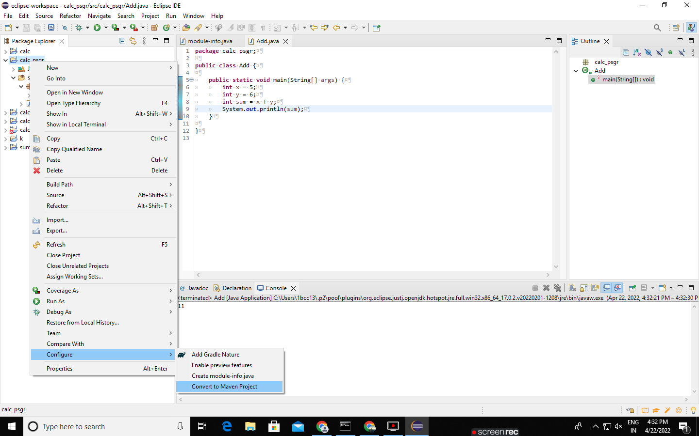

**Step 8:** In Create new POM dialog box, click Finish.

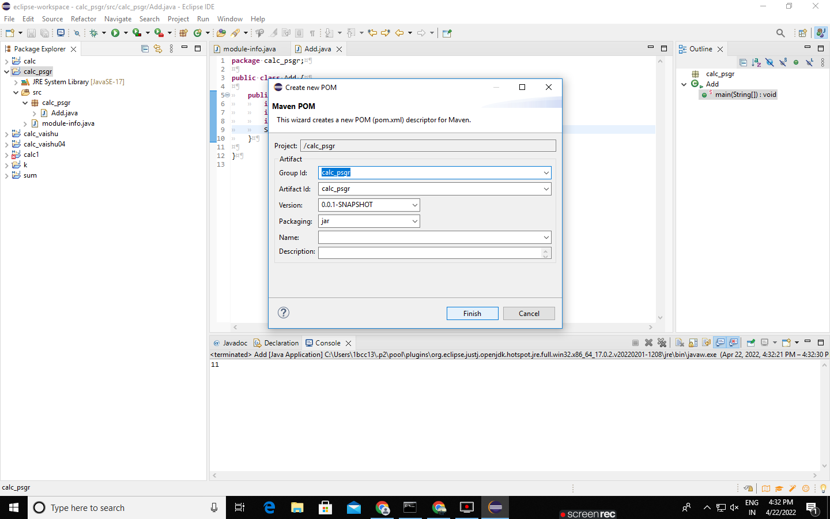

**Step 9:** To build Maven, select calc_psgr -> Run as -> Maven build

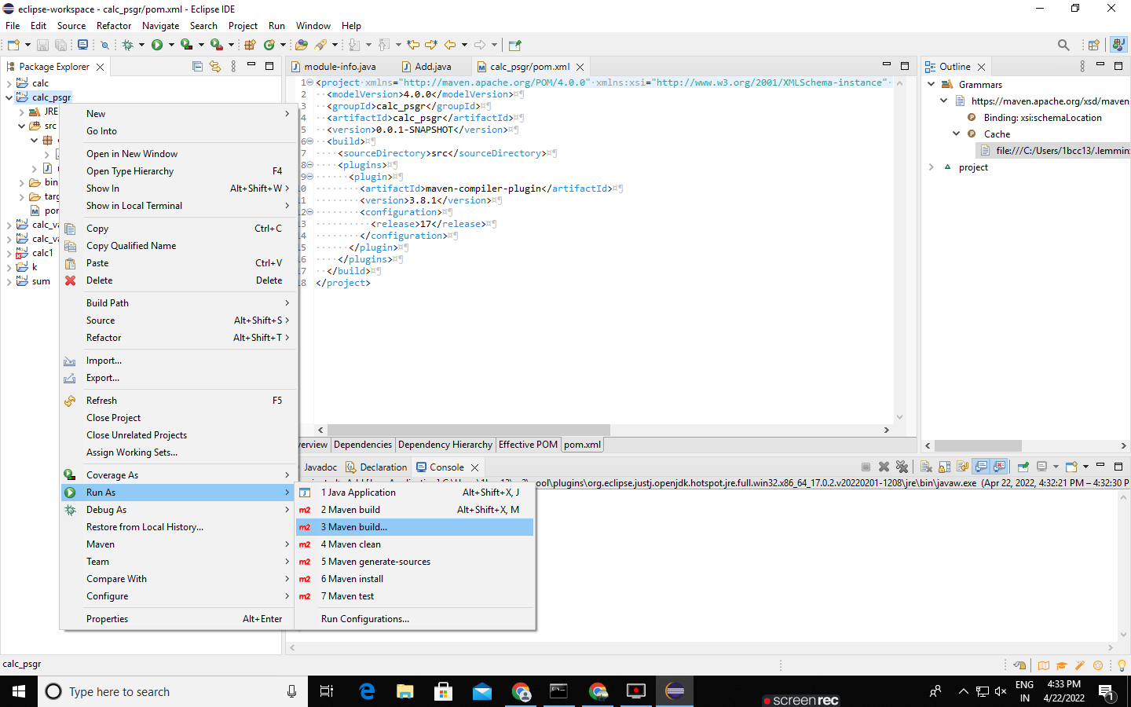

**Step 10:** In Edit Configuration dialog box give Goals as ‘package’ and click run

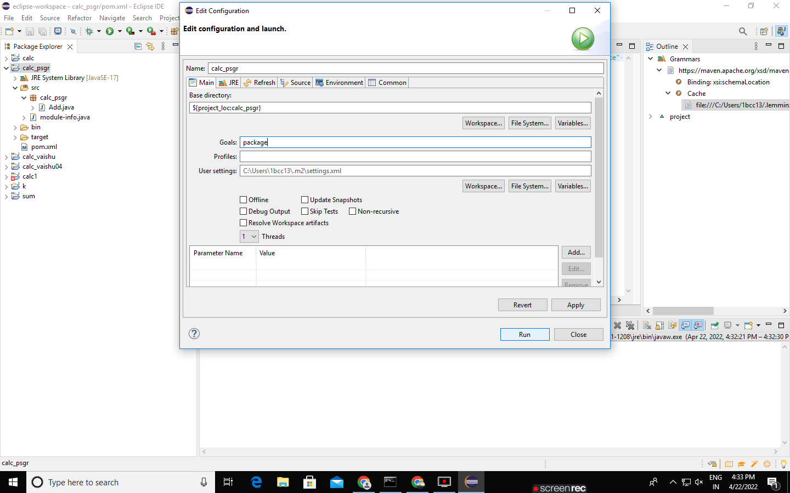

**Step 11:** Now Jar file is successfully build, copy the jar file address and paste it in file manager address bar.

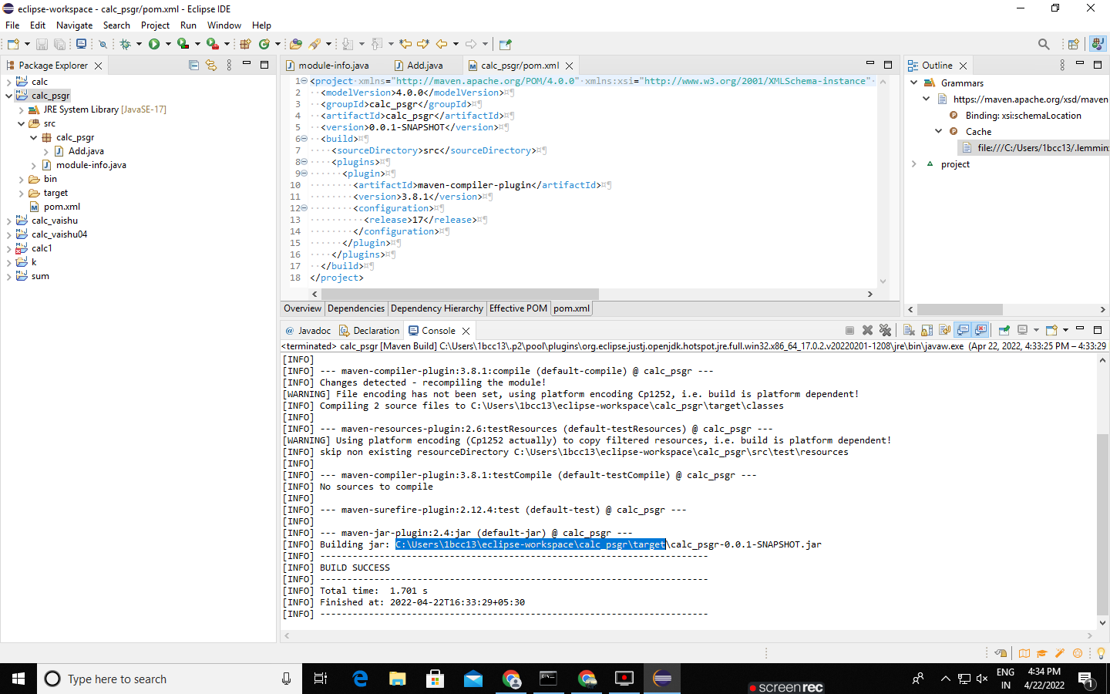

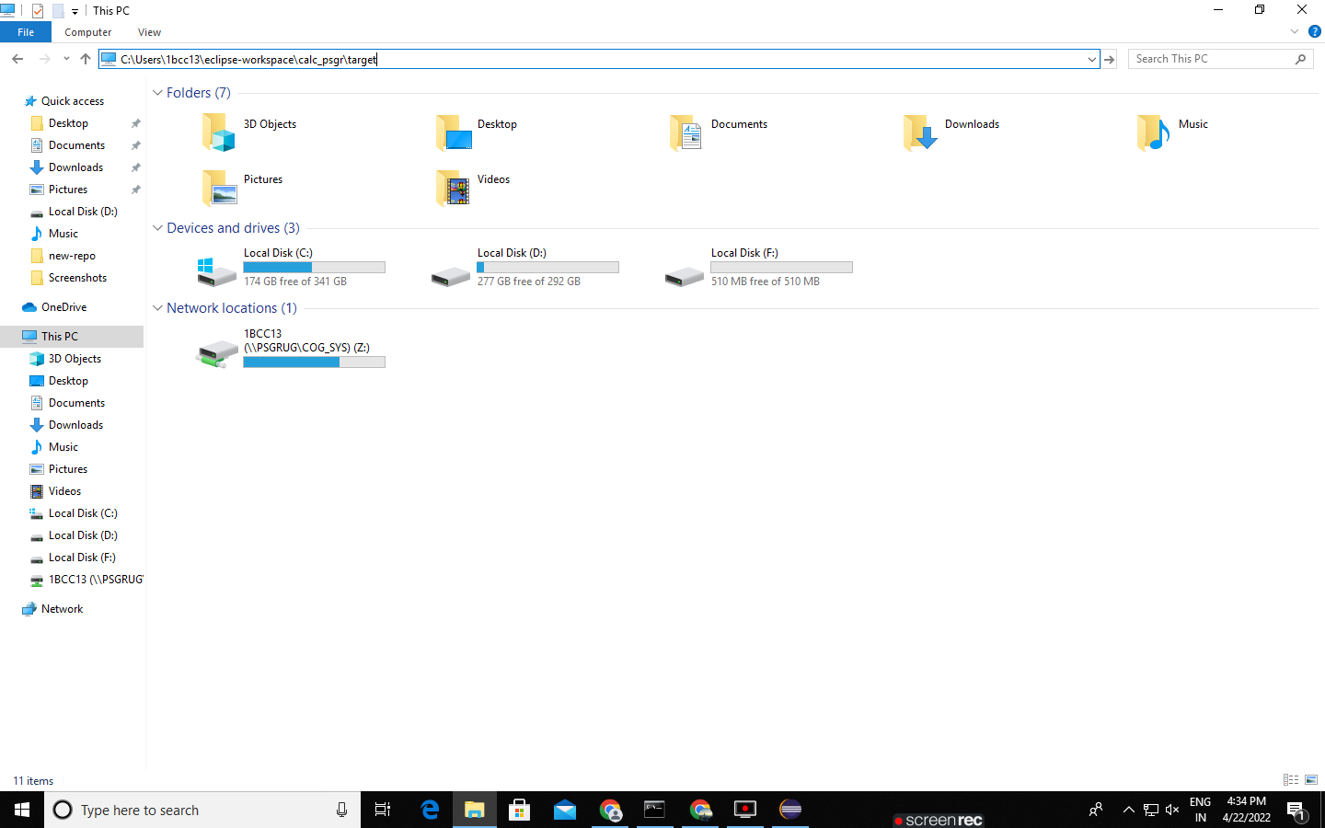

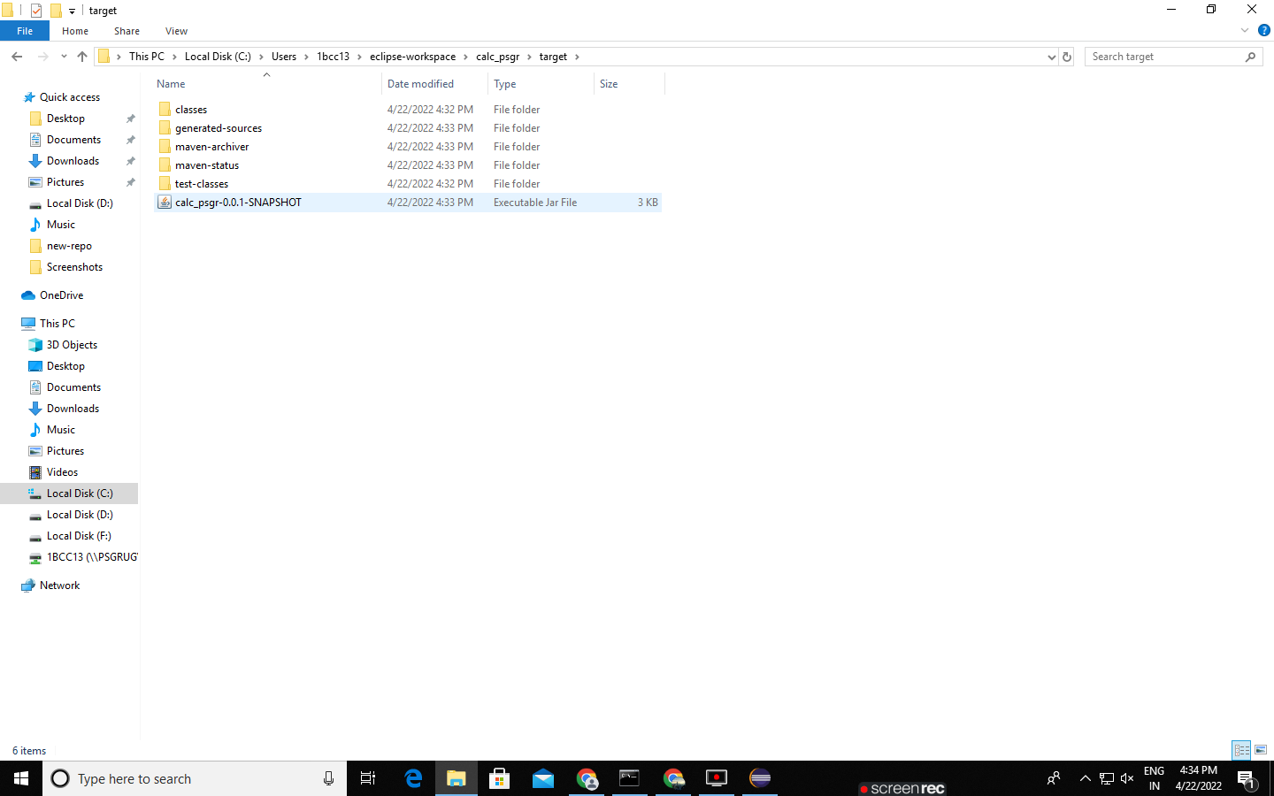

RESULT:

Thus we successfully build the jar file using maven in eclipse.

**PULL, RUN AND DELETE A DOCKER IMAGE IN WINDOWS**

**AIM:**

To pull, run and delete a docker image in the local machine.

**ALGORITHM:**

* Step1: First of all, sign up to the docker hub by simply typing “Docker hub” in your browser.
* Step2: If you already have an account then just sign in to the docker hub account.
* Step3: Once signed in, scroll down to see a list of official docker images which are available for free in the remote repository.
* Step4: Now open the command prompt.
* Step5: Type ‘docker images’ in order to see the list of Docker images on the system, this command is used to display all the images currently installed on the system.
* Step6: As we didn’t installed any image yet, it would be empty.
* Step7: Let us choose a simple image centos from the docker hub.
* Step8: Using the ‘docker search centos’ you can see the details of the images with the particular name.
* Step9: By typing the docker command ‘docker pull centos’ we can download a docker image locally on the host from a public or private registry.
* Step10: Now by using ‘docker images’ command we can see that the image we pulled is listed.
* Step11: Use the ‘docker run -it --name First_centos centos’ command in order to start a container from the hello-world image, where First_centos is the container name.
* Step12: This command will open the docker shell there type ls to list the files available.
* Step13: Now to get back to our normal command prompt, type exit or press ctrl+D.
* Step14: Using the ‘docker container ls –a’ command you can list the containers and confirm that all the containers are exited.
* Step15: In order to delete a container use ‘docker container rm container_id’ command.
* Step16: Also to delete a docker image from our local machine use ‘docker rmi image_id’ command.

OUTPUT:

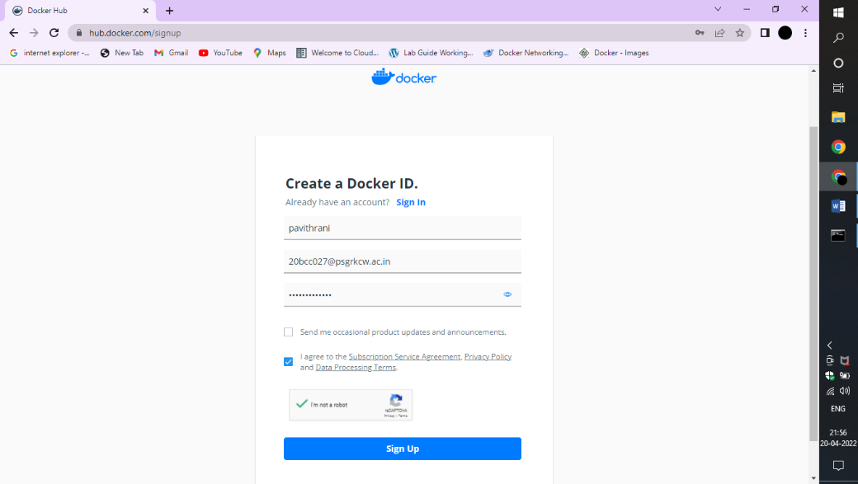

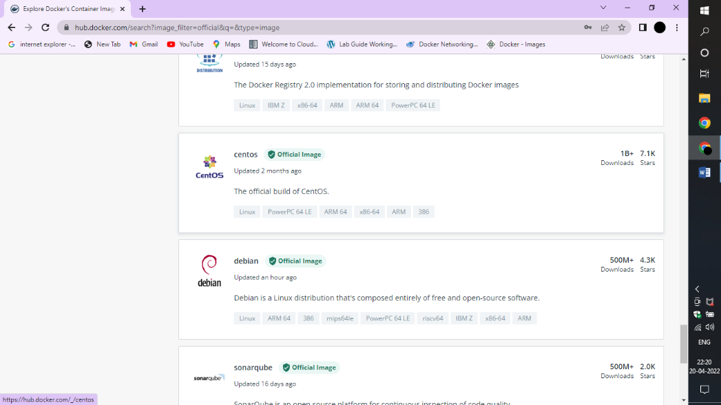

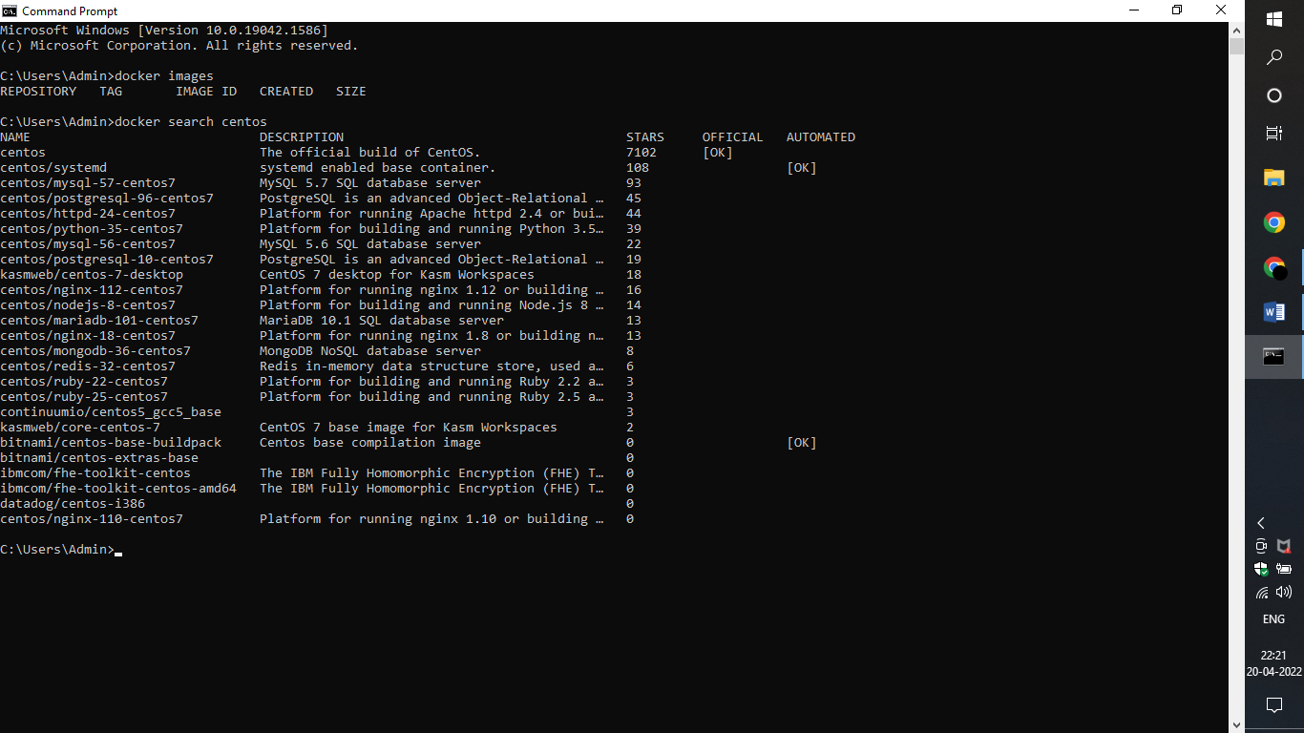

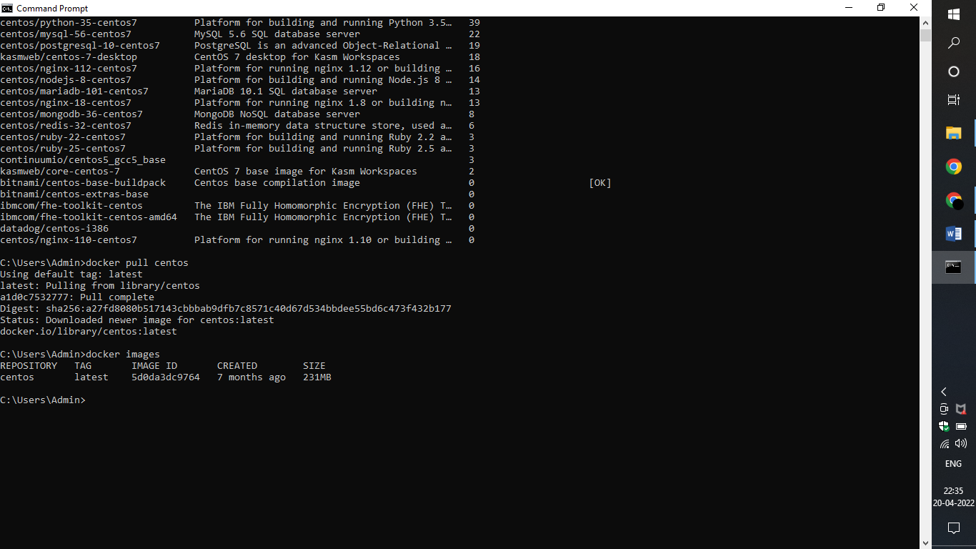

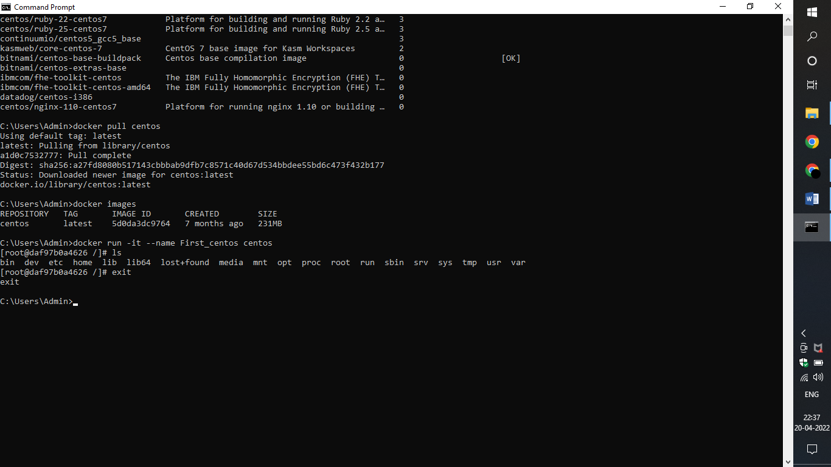

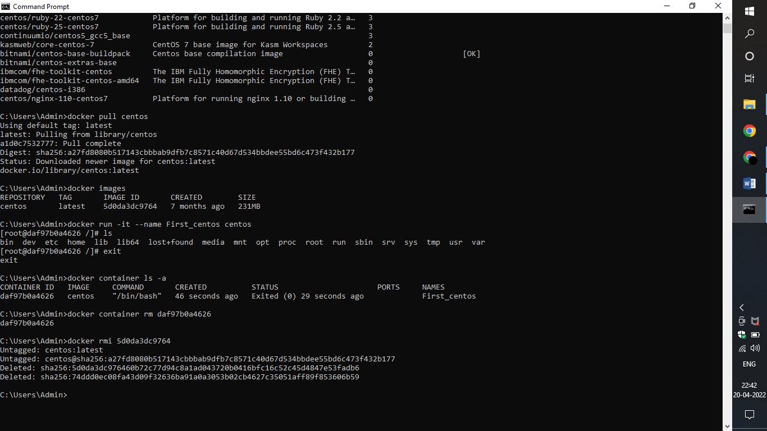

**RESULT:**

Hence a docker image is pulled, ran and deleted successfully.

**WORKING WITH DOCKER NETWORKS**

**AIM:**

To list, inspect, create, connect, disconnect and delete docker networks in local machine.

**ALGORITHM:**

* Step1: First of all, to see the list of networks available in our local machine use ‘docker network ls’ command.
* Step2: You can see the default networks listed with their id, name, driver and scope.
* Step3: In order to view the information of any network type ‘docker network inspect bridge’ where bridge is the network name, you can also use network id instead of network name.
* Step4: Using the command ‘docker network create --driver bridge psgr’ you can create a new network named psgr in the bridge driver and check it with ‘docker network ls’.
* Step5: Now in order to connect a network to a running container we must need a container with an image.
* Step6: Install an image using ‘docker pull centos’ and run it in the container using the ‘docker run –it --name First_centos2 centos’.
* Step7: To detach from the running container without stopping it press ctrl+p and ctrl+q.
* Step8: For confirmation use ‘docker container ls –a’ to check if the container is still running.
* Step9: Using the command ‘docker network connect psgr First_centos2’ to connect the network to the running container First_centos2.
* Step10: To check if the network is connected type ‘docker network inspect psgr’ where you can see the information about the connected container.
* Step11: Now use the command ‘docker network disconnect psgr First_centos2’ to disconnect the network from the container and again you can cross check it with ‘docker network inspect psgr’.
* Step12: In order to remove the network from your local machine type ‘docker network rm psgr’ command.
* Step13: Check if it is removed using ‘docker network ls’ command.

OUTPUT:

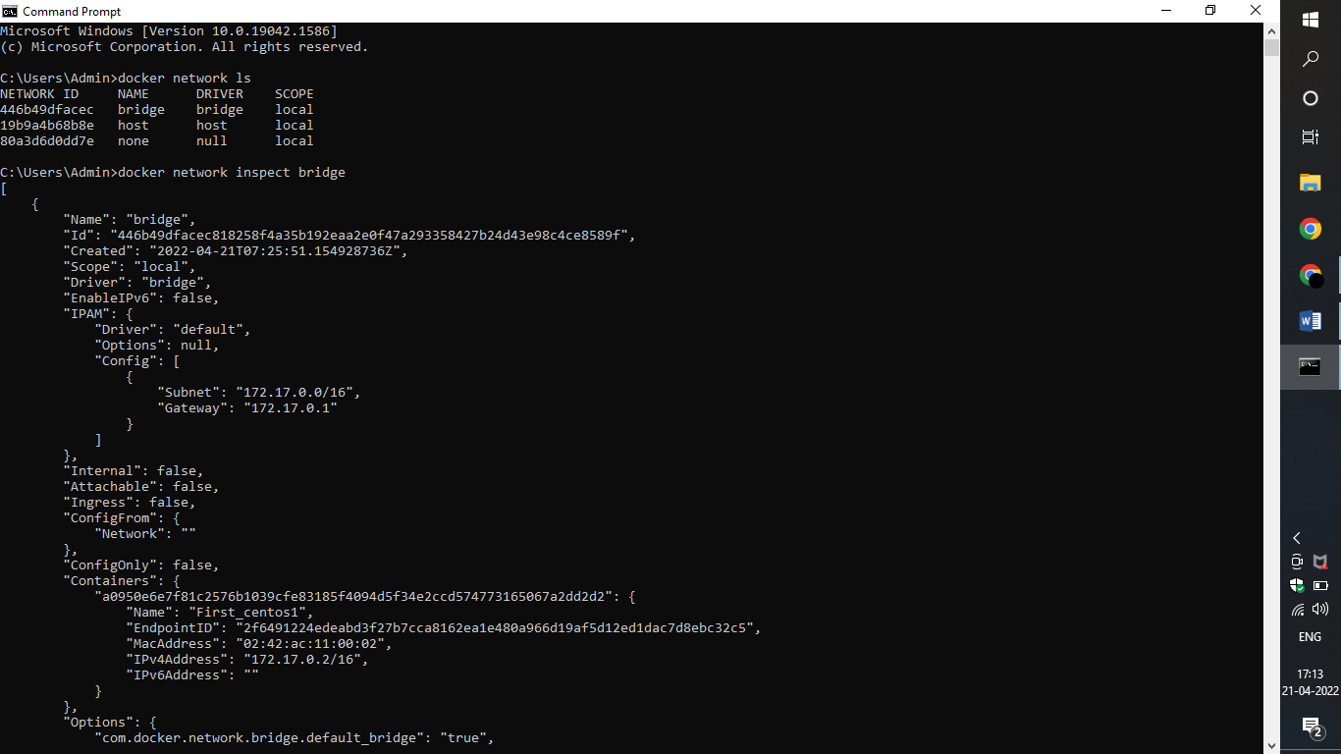

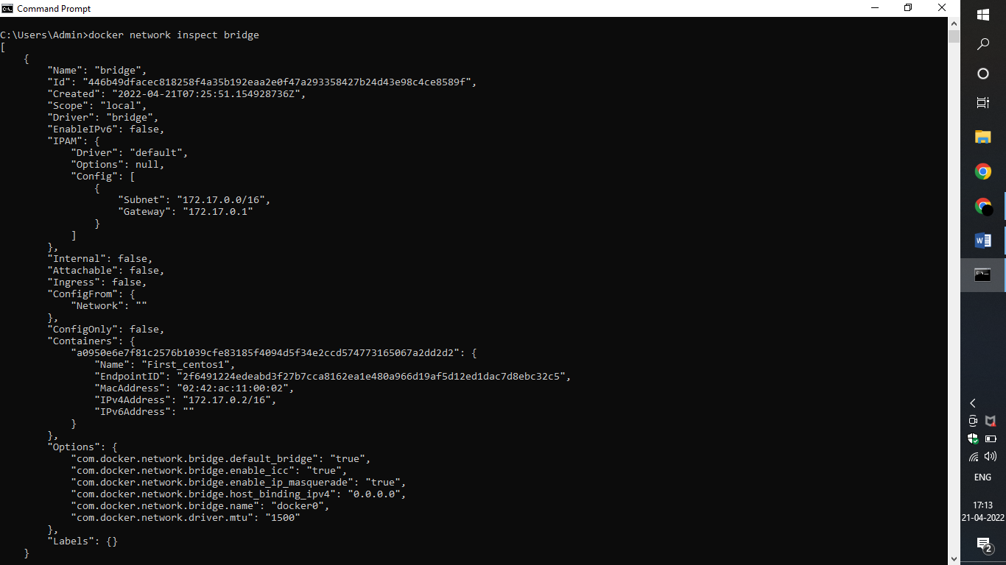

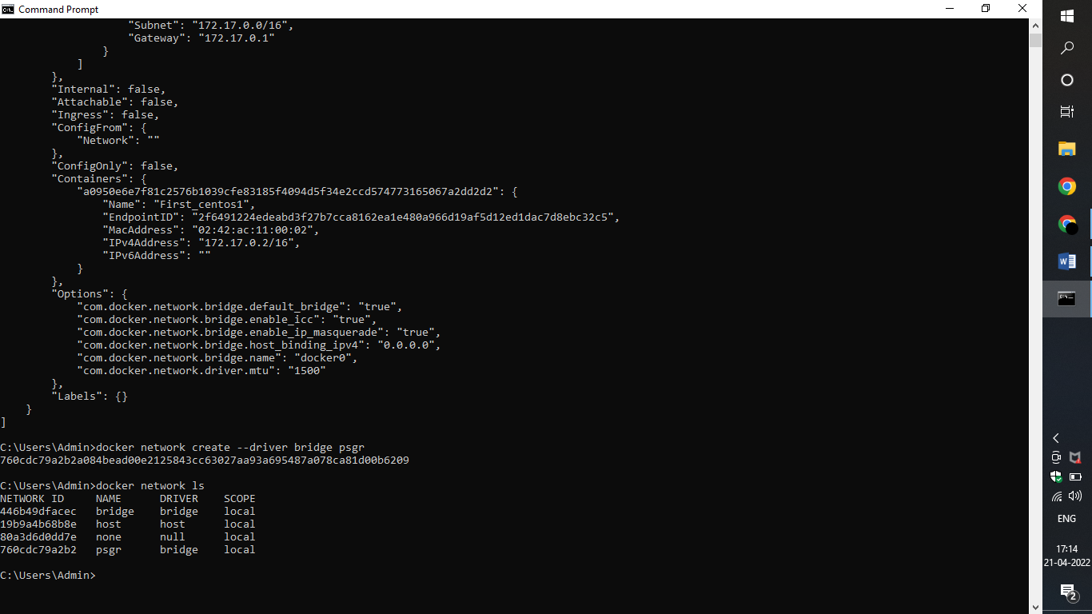

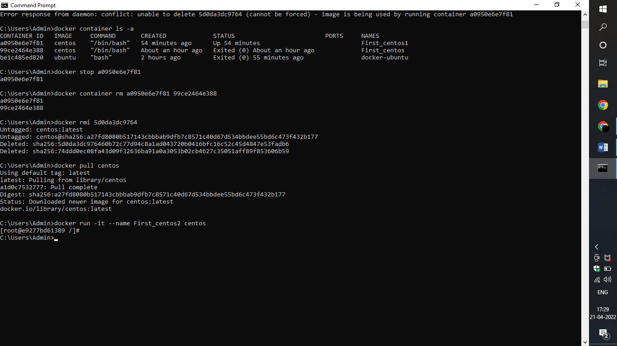

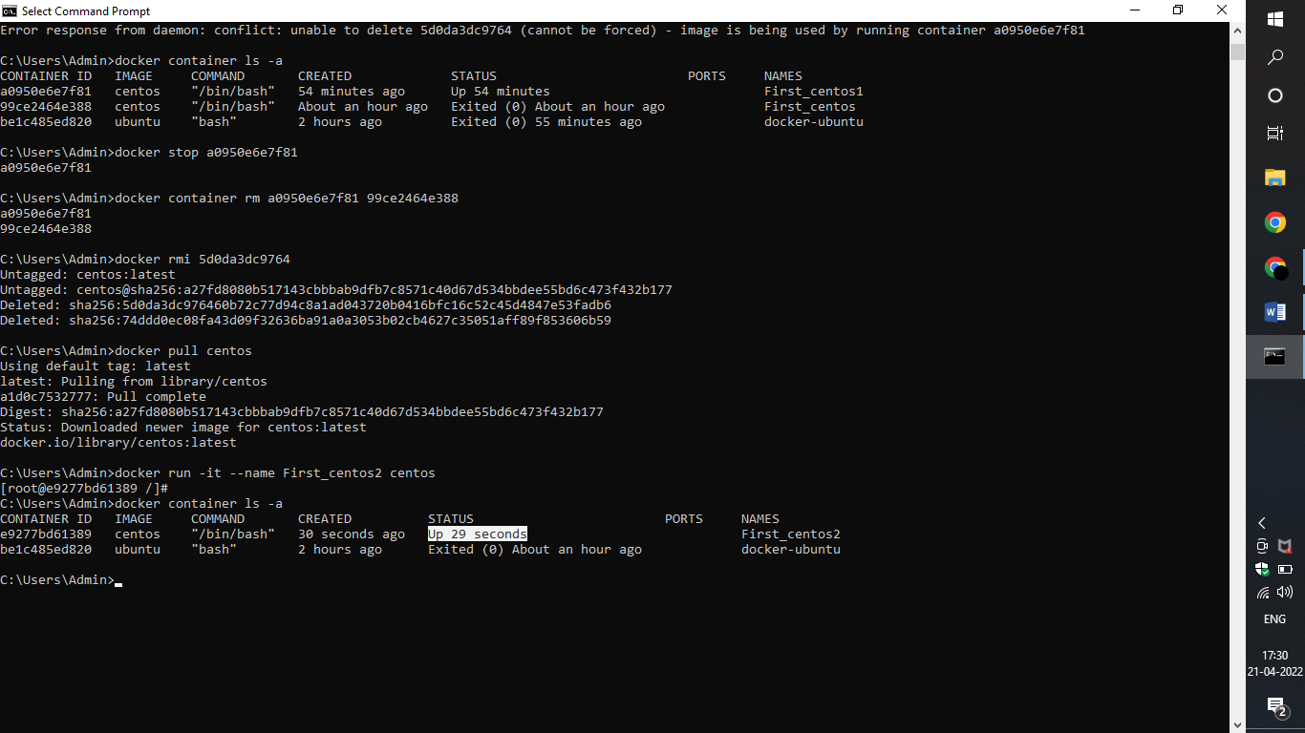

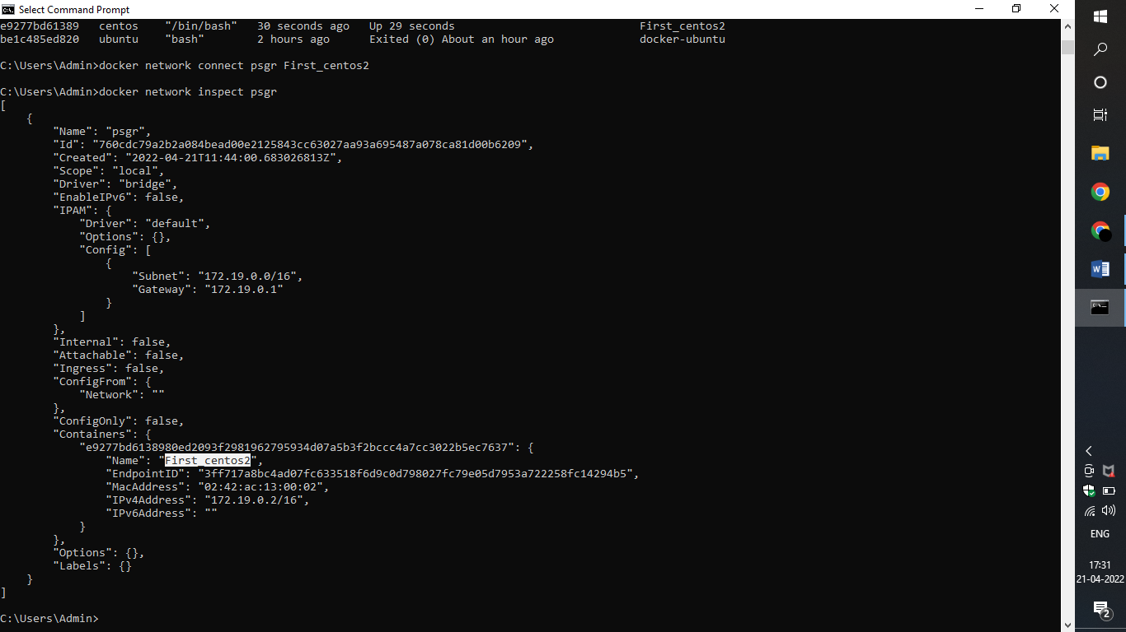

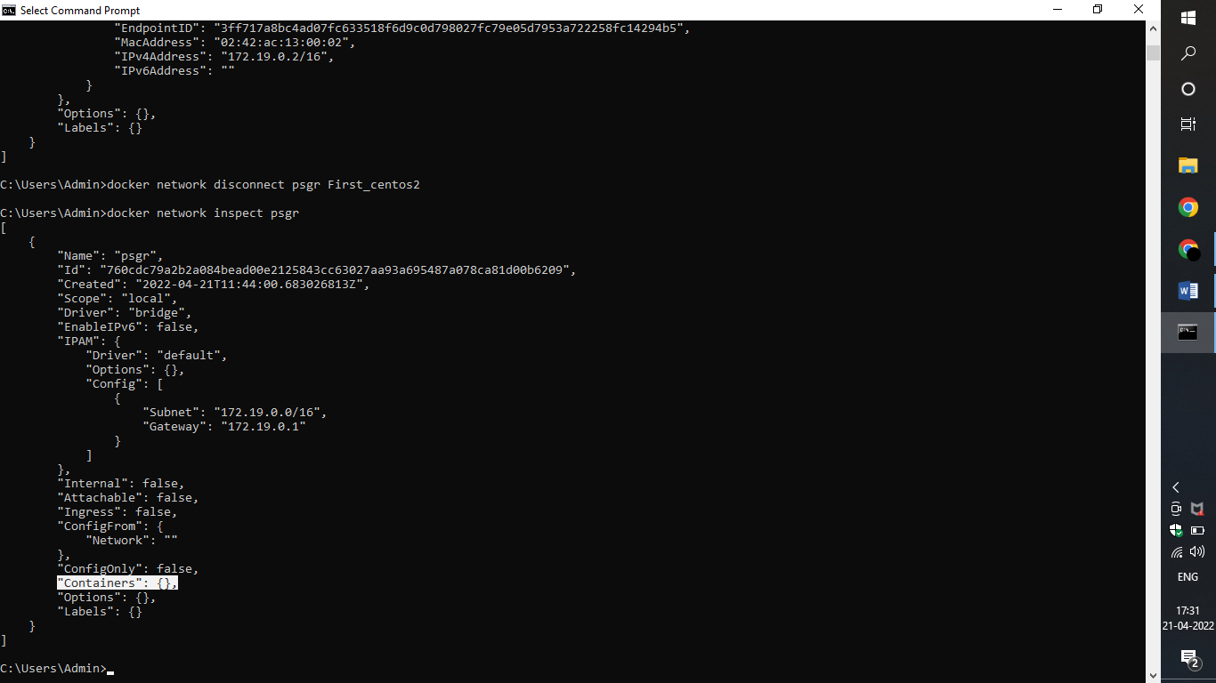

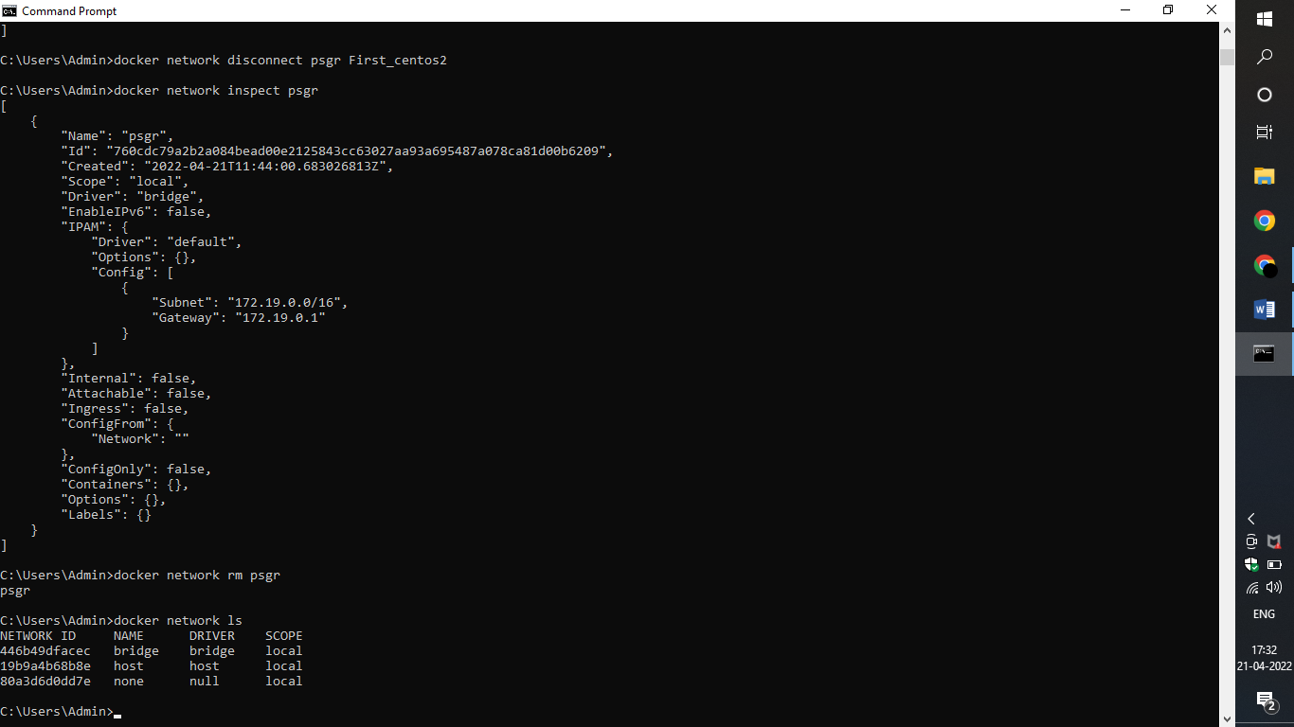

RESULT:

Hence a docker network is listed, created, connected, disconnected and deleted in a local machine successfully.